ACKNOWLEDGEMENTS.
This Centenary book is a continuation of the '80 year's anniversary book' written in 2004. The information has been added to and lists updated for a more complete record of the choir.
We unfortunately lost one of our earliest members, Sidney Clark, who joined the choir circa 1928, after his father was asked to take Sid along to Lord Halifax’s home on Christmas Day to sing Christmas carols, after dinner, for his guests. He was well rewarded with a shining 2/6d piece (half a crown) and instructed that this was for him only, his father was also ‘accommodated’. So there is no-one left for those first hand memories of the very early days, but long serving members can still make the hair curl.
Millions of people worldwide sing for pleasure, their own and for others. But for an organisation of part time singers, to keep the standards and impetus required, and continue to delight audiences worldwide, and to keep their hard earned reputation for 100 wonderful years is a momentous occasion.
As with all successful organisations, there are many people to thank for their various contributions, but the first on my list must be a very dear friend and colleague, who sadly passed away on January 17 2004. He ‘loved’ this choir and did anything and everything he could for it. He was a member for 38 years, 34 of which he served as an official. He served as secretary for 30 years, treasurer for ten and he performed both roles with flair, eloquence and total responsibility.
He was, of course, the late, great, Eric William Hill, married to the official choir accompanist Irene. More on both later, but for now, may I dedicate this book to his loving memory, for with his constant alertness and encouragement, his relentless edification and his sheer determination, this choir is all the richer.
To Irene Hill who first played for the choir at the age of 13 then progressed to be the official choir accompanist at 17 years old. She is undoubtedly one very talented lady. Many people play the piano well, but to accompany a male voice choir takes something really special, Irene had that something and used it to her best ability all the time. She has cajoled, shouted and coaxed this choir for many happy years and is our sternest critic.
Both Irene and Eric always put maximum effort into everything they ever did and our gratitude goes to both.
The choir is very fortunate to have had an assistant accompanist in 1997 to help Irene, in Mrs. Betty Heatley. Another very talented and knowledgeable lady, keeping us in line and never shy about her opinion. She also played for various soloists and the octet.
To Mr. Colin Leech, who joined the choir in 1963 as Musical Director and Conductor, who is responsible for the ‘sound’ in the ‘Thurnscoe Sound’ and for the majority of the honours bestowed upon the choir since 1964, we thank him for sharing his vast experience and knowledge with us and cajoling us to do our best. Sadly he passed away on his 72nd birthday in 2008.
Peter Snipe took over as M. D. for a couple of years and then was succeeded by Mr. A W Jermy
To the many officials of the choir over the years, for having enough forethought to archive records from which I collate much of this book’s content.
Ultimately, to every member, past and present, because without you, rehearsing and performing, there could never have been a ‘Thurnscoe Harmonic Male Voice Choir’.
To borrow the word’s of Mr. R (Bob) Roper in his 30th anniversary report:-
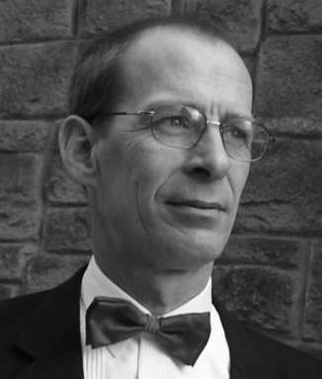
“During these years the choir has earned a reputation that is the envy of many fine male voice choirs, a reputation for really fine singing, good sportsmanship and always being willing to help charitable, religious and other organisations. This reputation has not been gained by one man alone, but the choir as a whole, by each individual member realising his responsibilities, by a great deal of hard work and sacrifice by past and present members. The choir and its reputation are something we should all be proud of".

Thank you all. John Keating.

What can we say about Eric Hill,
Eric W Hill by John Jefferies.

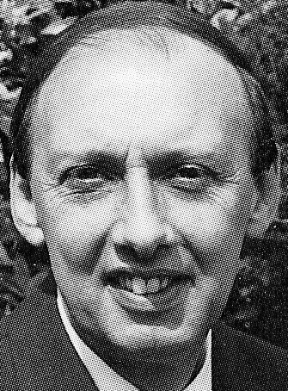
As treasurer and secretary he topped the bill, Writing and figures were his thing,
Which allowed us more time to sing.

Collecting the subs, tote and bonus ball, Nothing was too much, he did them all, He sang as a bass all his adult life, Supported by our pianist, Irene, his wife.

Throughout Wales and England, also overseas, Along with his mates he aimed to please,
Concerts and Festivals, he spread this choirs name, Then television and radio, brought still more fame.

Eric helped create the 'Thurnscoe Sound', Promoting our music all around,
Then when we were relaxing, in our home, He’d be writing letters, or on the phone.

Yes, the thing about Eric, you must admire, He worked tirelessly for his beloved choir, Even as his health declined, over the years, Which we all know now, sadly, ended in tears,

A real hard grafter, to the bitter end,
To the choir, a Treasure, a colleague, a friend.
Our thoughts are with Irene, Beverly, grand children two, Irene, keep playing, HE would want you to.

Eric W Hill John Jefferies.
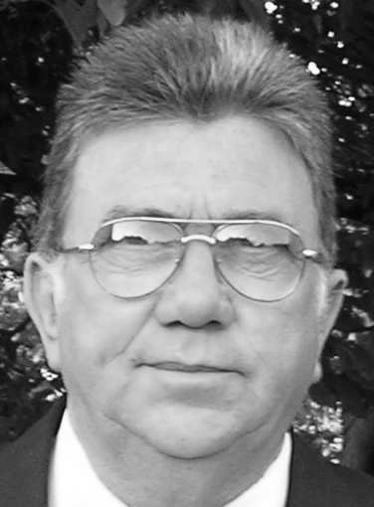

ASPIRING TO SONG. By George Johnson
George was a much valued member of the choir, holding various seats of office during his membership. He served on the commit- tee, became chairman in 1970 until 1980. In 1986 he became President until his death in 2002. He was a chorister and bell ringer at Barnburgh Church, joining Thurnscoe in 1965. He was awarded Honorary Life Membership in 1998. George gave valuable service to the choir along with his late brother Albert.
A Rhyme of Titles
From the songs they learned at mother’s knee, To singing songs of praise, Full round the clock our lads would sing, Their voices, blended, raise, Religious? Yes, ‘Abide with me’, Your favourite? Well, just wait and see.
‘The Lord’s my Shepherd’, even though, ‘I’m a Broken Hearted Milkman’, so I’ll,
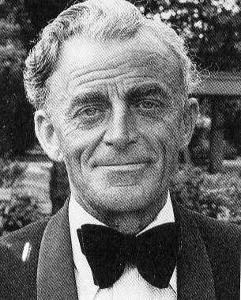
Take you out in a ‘Surrey with a Fringe on Top’, ’Till, ‘The Long Day Closes’, near, ‘Framilode’, Where, ‘The Old Woman’, Sits on a bank near, ‘Two Roses’, fair,
She’s, ‘Just a Wearying For You’, and, Prays for a, ‘Silent Night’, ‘How Sweet The Moonlight Sleeps Upon This Bank’.
‘Arise O Sun’ with ‘The Jovial Beggar’, And accompany ‘The Vagabond’,
‘The Donkey’ will ‘Speed Your Journey’, Or ‘Row, Boatmen Row’ over a ‘Deep River’, Out to ‘The Fighting Temmararie’ to, Join ‘Bobby Shaftoe’ where on,
‘Some Enchanted Evening’ ‘It’s Impossible’, To get ‘Shortening Bread’ so, Listen to the ‘Soldiers Chorus’ because ‘Their is Nothing Like A Dame’, When ‘She Walks In Beauty’ and ‘My Love Is Like A Red Red Rose’.
Then ‘Blow Blow Thou Winter Wind’, Whilst we partake of ‘Italian Salad’, At ‘The Feast Of Feasts’ or ‘Steal Away’, And hear’ The Pilgrims Chorus’ in, ‘Tranquillity’ on ‘Newlyn Hill’. ‘O Peter, Go Ring Dem Bells’
‘Around The Mighty Dome Of Paul’s, Whilst we go ‘Marching To Zion’, Accompanied by ‘Seventy Six Trombones’ or sing the ‘West Sussex Drinking Song’,
As we pass by ‘Linden Lea’, we’ll ‘Climb Every Mountain’ pursued by ‘The Bold Gendarmes’ Let ‘Tenor And Baritone’ watch out, For ‘The Cavalry Of The Steppes’,
On ‘The Road To Mandalay’ or on, ‘The Return’ from ‘Finlandia’,
‘The Herald’ welcomes us ‘Into The Silent Land’ and we Shall know ‘Nirvana’.
‘JUBILATE, AMEN’.

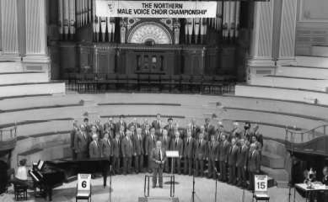
The ‘THURNSCOE SOUND’ By Albert Haigh.
Not in town or city swell, but in a village, where miners dwell,
The old folk talk of days gone by, recalling dear friends with a sigh, Of men who met to form a choir and started a movement, to inspire,
Men of song and men of vision, who gave themselves a special mission, To express themselves with heart and soul, striving towards a special goal,
The conductor guiding, cajoling, praising, that elusive quality, ever chasing, Tenor, Bass and Baritone section, seeking tone and pitch perfection,
Till at last, they finally found, that wonderful, beautiful, Thurnscoe Sound, Now singers come from far and near, to join this choir we hold so dear,
Making vast efforts and giving up time, that we may enjoy their music, sublime,

Reaching standards of the highest acclaim, befitting of the Thurnscoe name, Always giving of their very best, that we may feel, enriched and blessed,
Thank you choir, your conductor too, and the lovely pianist’s who accompany you, We hold you in the highest esteem, for together you make the perfect team,
When the trumpets of the Lord shall sound, and time shall be no more,
When the men who make the Thurnscoe Sound, shall stand at Heaven’s door, All the angels, shall applaud, as these gallant gentlemen,
Stand before their God and sing, that final, great, Amen.
Above.
48 members await the adjudicators permission to continue at Huddersfield Music Festival.

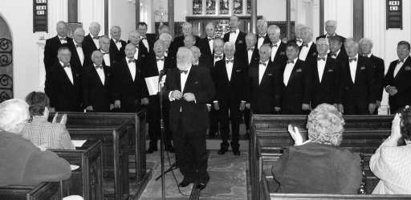
Left.
July 2004 Christchurch, Brampton Bierlow.
One of two anniversary concerts sang in this wonderful venue.

A Lifetime of Song. In the beginning.
Migrants from all over England and beyond came in their hundreds to earn a living in the newly sunk mines in and around the ever expanding village of Thurnscoe, South Yorkshire. That was in 1890. Over the ensuing 30 years or so, churches, chapels and everything associated with a thriving community were built and Thurnscoe became a successful, working community, complete with football and cricket teams, brass bands and of course, the Thurnscoe Harmonic Male Voice Choir.
It was 1924, few male voice choirs existed, but one such choir agreed to help raise funds for a local church restoration, and these singers were very proud of the fact that they were all miners. The congregation, including a bunch of local miners who enjoyed singing, were totally amazed that such a bunch of rough looking lads could perform with such talent, versatility and beauty of expression throughout their repertoire of hymns and songs. As soon as the performance had finished these men surrounded the choir and bombarded them with questions about the excellent close harmonies and how to set up a choir themselves. Those lads in the audience that evening were intent on forming their own male voice choir. The visiting choir's leader explained that they first needed to find a leader themselves, to conduct and keep everyone singing together as one ensemble. He promised the lads that if they could learn to sing without copies of music, he would return and give them the benefit of his knowledge and assess their progress. Through their great love of singing, inspired by the great church and chapel choirs that were abundant locally and of course this visiting male voice choir, this group of miners gathered in the Primitive Methodist Chapel, on 23rd September 1924, to discuss the forming of a Male Voice Choir.

All script in Italic from this point on is an extract from the minutes of the time.
The minutes of that very first meeting are on record :-
‘Public meeting held in Primitive Methodist Chapel, Thurnscoe East. Mr. F. Tulley voted to take the chair.
The meeting unanimously decided to form a Male Voice Choir.
Proposed by Mr. E. Carver and seconded by Mr. G Beardshall that Mr. C Fretwell be appointed secretary. Carried unanimously. Proposed by Mr. G Beardshall and seconded by Mr. E Carver that Mr. D Evans be appointed Conductor. Carried unanimously. It was decided that the secretary send for 12 copies of ‘The Long Day Closes’. The first rehearsal to be held on Friday 26th September 1924.’
The next entry in that minute book says,
‘General meeting, 26th September 1924.
Meeting held in Primitive Methodist Chapel at close of practice.
It was proposed by Mr. G White and seconded by Mr. Robinson that Mr. F Tulley be appointed to take chair at all meetings of the choir. Carried unanimously Mr. J Smith proposed and Mr. G Speight seconded that Mr. I Ball be appointed treasurer. Carried unanimously.
Proposed by Mr. G Speight and seconded by Mr. E Smith that a committee of five be chosen from the members. On being put to the meeting the following gentlemen were selected as committee: - Mr. F Powell, Mr. J Glover, Mr. I Glover, Mr. G Davies and Mr. G Beckham and it was proposed by Mr. C Mason and seconded by Mr. G Speight that all the above be selected. Carried unanimously. Addition to the previous minute proposed by Mr. Robinson and seconded by Mr. E Carver that the committee have the power to add to their number should the necessity arise.
It was agreed to leave the matter of arrangements respecting practice room in the hands of the committee. The secretary to notify the members of the time and place. It was moved by Mr. Robinson and seconded by Mr. E Carver that the secretary writes to the
U. D. Council applying for use of the parish hall. Carried unanimously.
Mr. D Evans stated that he did not think it was necessary to have a general subscription, but he suggested that a levy be made upon the member when funds were required. The members unanimously fell in with Mr. D Evans suggestion and it was further agreed that members paid for their own music on receipt of same from the secretary. The secretary was instructed to send for a supply of copies of ‘Hymn before Action’.
Proposed Mr. G Speight and seconded Mr. I Ball that the choir be named “Thurnscoe Madrigals”.
An amendment by Mr. E Carver and seconded by Mr. Small that the choir be named “Thurnscoe Harmonic Male Voice Choir”. The amendment was carried unanimously. October 10th 1924,
We had been offered the use of the Primitive Methodist Chapel for rehearsals.
A 1/- (one shilling - 5p) levy to be made with a view to forming a working balance. Carried.
Enter Wombwell Music Festival, Nov 21st 1924. Carried. (No further information can be found about whether they attended or what the marks were)

November 9th 1924.
The secretary to issue blank cards for members to fill in to assist him forming a register of members.
The U D Council had offered the use of the parish hall for rehearsals on a Sunday morning, at a cost of 3/6d per morning. Carried.
It was decided to set subscriptions at 1/- per month. Carried. It was decided that Miss Alwyn Evans become official choir accompanist. All the above put to the choir and accepted.

November 26th 1924.
It was decided to perform a concert for the Primitive Methodist Chapel, free, but insisted that tickets be sold at no less than 9d each. It was decided to alter the subscription amount to 3d per week.
One or two of the union members amongst them suggested that they formulate rules for guidance and expectation and the birth of this great establishment was on its way.

It was decided to formulate rules and constitution, with the prime rule never to be changed.
With the finer details ironed out, they again began to rehearse with passion and vigour, with unity and purpose until, after only six months, the leader of the choir that had promised to return and review them, was asked to return and appraise their progress. He expressed his disbelief in their vast progress and encouraged them to enter festivals competitively.
The Cleethorpes Festival was not far away and if they worked hard they could be up to standard in time. The choir immediately doubled their rehearsal time in preparation for this, the first of a catalogue of festival entries. When the test pieces arrived they had never seen such difficult music, even Mr. Evans needed to take advice on the intricacies of these copies before the learning process could begin. They persevered with the grinding process of breaking each piece down and although often very frustrated, they began to win the battle.
The day of the festival dawned with nervous anticipation. As their rivals, Scunthorpe MVC, with their vast experience and flair, mounted the stage and began to sing, they listened in total awe. They expressed apprehension to their conductor, who calmly reassured them that they would not disgrace themselves. Then it was time for them to show what they were capable of. They stood proudly on that stage, each man giving his all, singing each test piece in turn. Afterwards they stood, red faced and proud of their performance at festival level, listening to and receiving their ovation. This was better than any drug or alcohol, but maybe a little ‘lubrication’ may have been taken after the adjudication, on the way home.
Prof. Hugh Roberton rose to deliver his adjudication first pointing out his learned opinion of Scunthorpe Male Voice Choir’s performance. He praised their phrasing and balance, magnanimously pointing out the finest parts of the performance. He then pointed out the few minor parts out, a performance just short of perfect. He then started his adjudication on the Thurnscoe Harmonic MVC performance. Only a veiled hint was given about the possible loss of tuning in a particular phrase.
Prof. Hugh Roberton (latter to receive a knighthood) continued with a general adjudication of the pieces and the expectations of an adjudicator. Everyone learned a little more that day about how to sing and express themselves better, through music. Both choirs felt that they were much richer for the entering of the competition.
Then came the marks. Scunthorpe MVC, 85 & 89, totaling 174 marks. Thurnscoe Harmonic MVC, 85 & 87, totaling 172 marks. Just two marks separating the two choirs. The adjudicator praised Scunthorpe but warned them that Thurnscoe were “hot on your heels”. He was then informed that Thurnscoe Harmonic was new to festivals and his praise was boundless, thus encouraging the lads to enter the very next festival, only two weeks away, with renewed vigour.
This festival was local to Thurnscoe, at the nearby Brodsworth (Hall) Music Festival, a matter of three miles east on the Doncaster road. They only had to learn one test piece and as no own choice was to be sung by any entrant, their lack of repertoire was not an issue. So they knuckled down to rehearse the test piece, being fully cognisant of the task ahead, with Prof. Hugh Roberton’s adjudication fresh in their mind.
On 18th July 1925, they arrived at Brodsworth Music Festival and were greeted by four very established and renowned choirs. They listened in awe as Bullcroft MVC sang with tremendous passion and verve. Then Bulwell MVC seemed to sing marginally better. By now they were very highly strung and very nervous. It was their turn to sing. The “Thurnscoe Harmonic Male Voice Choir” were announced to the waiting adjudicator and audience. They nervously made their way onto the stage and, after a moment to settle, they sang their hearts out, remembering every little nuance required by their conductor and finished on “a chord made in Heaven”. When they had finished singing, a silence filled the auditorium. You could hear a pin drop, for several seconds. Then, as if prompted, the whole audience erupted with a truly heartfelt ovation. These lads were totally euphoric as they left the stage, marching off with total pride. So much so that they did not get to listen to the fourth and fifth choirs, Sheffield Orpheus and Edlington.
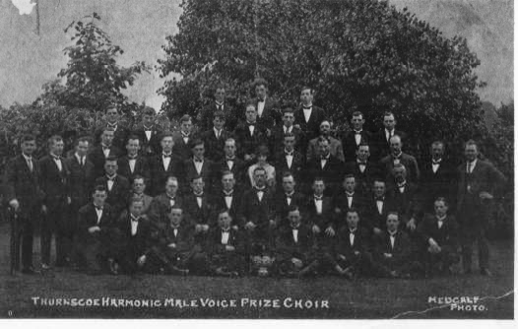
They returned after for the adjudication. Each choir, in turn, heard their respective adjudication, praise was abundant for all, as was criticism, each being advised on how to better minor points of their performance. When it came to Thurnscoe’s turn, they were skipped. The lads never expected this and were frantic with worry. Dismay was evident as they never received a word. After the final adjudication, the adjudicator turned to Thurnscoe, heaping praise at the strength and quality of their singing, expressing delight at the tone and beauty of even the soft phrases.

Left.
The first official photograph of the newly formed choir, proudly displaying their first of many trophies. 1925

Then came the time for marking. Bullcroft MVC - 67 marks, Sheffield Orpheus - 79 marks, Edlington MVC - 80 marks, Bulwell MVC 81 and finally Thurnscoe Harmonic MVC - 86 marks. Again, the auditorium burst into spontaneous applause from the audience, the adjudicators and all the other choirs. This was the start of a long successful competitive life for this choir. First place, at only their second entry into competition, just ten months after inauguration. Although full of pride, the conductor, Mr. D Evans, instructed them not to gloat, but to congratulate the other competitors. They did so with deepest sincerity and were amased to see and hear the respect and congratulations, in abundance, from their peers. The feeling of comradeship with their fellow music makers made this an evening to remember and they now knew that they could compete against the best choirs in the country. They rehearsed harder over the ensuing months and entered more competitions, always coming away with a placement.
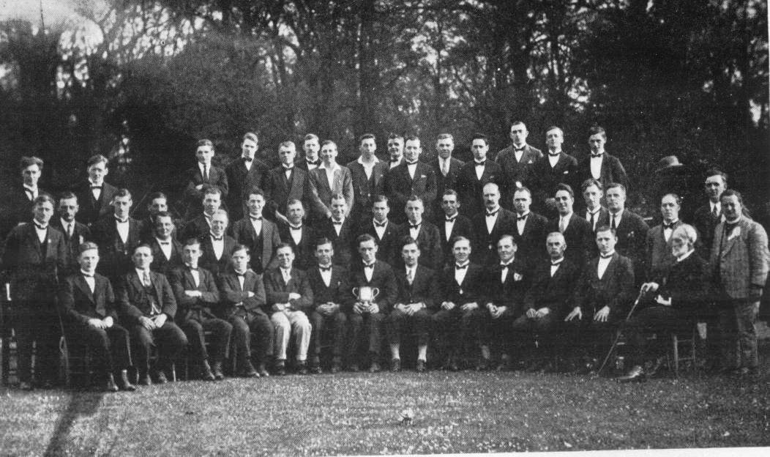
They now believed that they were at least as good as any other choir in the land, and would take on all comers.

The Archive History.
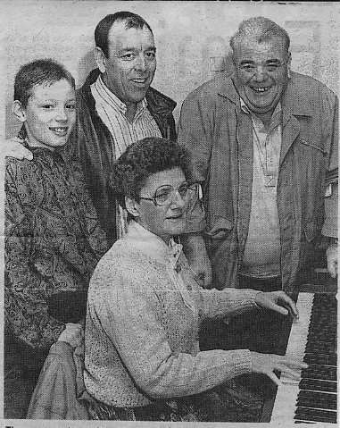
The choir, even in those very early days of 1924 & 5, had encouraged soloists, quartets, octets and various ensembles. In the following cutting and picture you can see founder member Mr. L. Cook, father of Mr. Frank Cook. This is by no means unusual in such organisations, I can remember old ‘Mac’, his son, Mick, and his son, Robert, all singing together. Uncles and nephews and many brothers, even father and daughter, husband and wife, brother and sister, all enjoyed the extended ‘family’ of the choir. I refer to previous conductors’ wives or daughters that have blessed us with their talents, either accompanying or conducting. Yes, one would expect male voice choirs to be predominantly ‘male’, but it’s not uncommon to have a ‘lady’ somewhere in the organisation, keeping the ‘lads’ in order. Many of the traditionalists would not voice the opinion that, where ever there is a female influence, it is normally a very strong one. But if the truth be known, certainly in my experience, that is the case.
The Octet of 1926. Mr. L Cook (2nd from right, back row) father of Frank Cook, honorary member today.
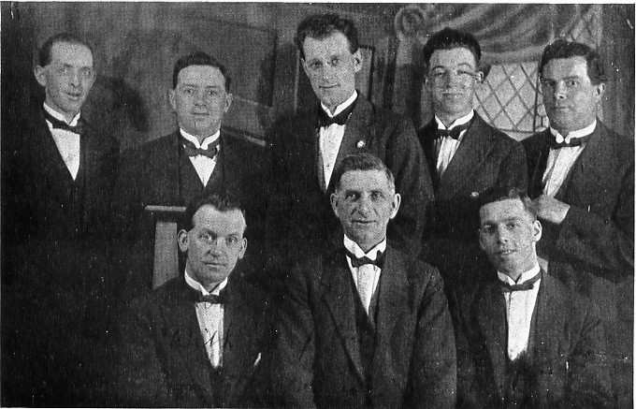
Right. Three generations of the McGrevy Family serving at the same time.
Granddad ‘Mac’, Michael and his son, Robert.

As our records show, the bulk of which is kept in safe hands at Barnsley archive services at the town hall, their largest archive collection for such an organisation, women have played an important role in the choir since day one. The following are extracts (in italics) from those minutes. Committee meetings were held at various times, usually on a weekly basis, due to pressures of work, before or during practice or after choir practices. 12th February 1925
Proposed by Mr. J Glover and seconded by Mr. G Davies that the choir has 50 membership cards printed save to show amount of contribution and rules.
(At a later meeting these were later fixed at a cost of 5d each, members to pay for their own).
The following rules were drawn up, it being proposed by Mr. I Glover and seconded by Mr. G Davies that the rules be recommended for the members’ approval.
1. The society be called ‘Thurnscoe Harmonic Male Voice Choir’. All meetings to be held in the practice room.
2 The affairs of the choir shall be conducted by a President, Secretary, Treasurer, Conductor, Vice Conductor, Librarian and Committee. five to form a quorum. (No mention of chairman, although he was normally there)
- Members shall pay 3d per week, such payment shall entitle them to attend practices or musical evenings arranged for the benefit or amusement of members only.
- The funds of the society to be used for the purchase of suitable music as the committee may decide for the welfare of the choir. (This later ‘struck out’)
- A member borrowing any music be responsible for its safe return and if torn or otherwise injured, shall pay such compensation as the committee shall deem fit. (Also ‘struck out’)
- The society shall not be dissolved so long as there are parts to sing a quartet. (Amended February 1925)
- The committee may alter any rule that does not refer to the dissolution of the choir, but such alteration shall not take effect until approved of by a majority of the members present at a general meeting.
- Members to do their utmost to attend practices regularly prompt to time. Amendments to the above were made on February 18th 1925.
The very first Annual General Meeting was held on the 11th October 1925, committee members were raised to nine members, after indecisive vote. It seems here that the choir, after just 12 months, were so busy that more help was required on the committee. A ballot of the four applicants was taken, there being only three required and the votes were tied. It was proposed, seconded and carried unanimously that all four should take a seat on the committee.
December 2nd 1925. E Smith asked to become vice conductor’. Accepted
Although this choir had a taste for competitive singing, they still held concerts, nationwide, in support of various charitable causes, amongst them the miners’ wives and children, raising small fortunes during the 1926 strike. Still rehearsing in the chapel rooms, they also held, very popular ‘ham & tongue’ tea socials and dances, in abundance, recorded at intervals of approximately 3- 4 months apart. Their generosity was also abundant, as minutes show on 18th April. “...The secretary announced that the funding from the council for the concert performed for Thurnscoe scout sports fund had not been forthcoming and had been denied. In respect of this we have waived our fee. When announced to the members this was unanimously approved.”
Offer made to do concert for Primitive Methodist Chapel in respect of using rooms for rehearsal, or a donation to be given for same of £2.
Three more local charitable causes were granted concerts at this meeting at no charge. It was also proposed, seconded and carried unanimously that the choir makes a grant to Mr. D Evans ...’as a slight recognition of his service and sacrifice’.
On 5th June, Mr. J Glover was asked to resign as treasurer and Mr. E Smith was voted to take over. No explanation was recorded as to the reasons for this.
On the 5th July 1926, Mr. David Evans resigned as conductor, due to being offered promotion and work in Brighton. The choir was devastated, he had taught them everything they knew, he had taught them how to be the very best they could. They humbly accepted his resignation, as his new position started on Monday 6th July and promised him that they would make every effort to continue. A vote of gratitude was put on record for all his efforts.
They appointed Mr. Ernest Smith as conductor and Mr. E Carver to take over as ‘vice conductor’. Both men addressed the choir and ‘spoke in appreciation of the honour the choir had bestowed upon them and signified their willingness to do their utmost, for the honour and glory of the choir’.
19th July, Mr. J Biddleston had been invited, while holidaying in Warrington, to bring the choir up for a series of concerts to raise funds for The National Social Committee for the relief of 'Miners Wives and
Childrens fund'. The secretary was instructed to write to their H Q in London to gain authorisation. The
application was successful and the secretary advised Warrington that authorisation had been granted, the choir was ready to come ‘at one day notice, providing no member would incur one penny expenses’. At the same meeting, invitations from Great Houghton & Goldthorpe convalescent committee to assist in the annual hospital sing were considered. Dependent on the Warrington dates, the choir voted unanimously to attend on 8th August at the ‘hospital demonstration’.

30th July 1926. ‘Proposed Mr. E Carver and seconded Mr. J Myers that the secretary be instructed to obtain copies of the test piece for Elsecar and sample pieces for Mexborough Music Festivals. Carried.
This latter proved to be one of the choirs’ best ever decisions.
August 16th. A letter came from Warrington stating that two concerts had been arranged for 28th August. The choir was less than pleased, it was proposed, seconded and unanimously agreed that if more concerts were not arranged, it would not be worthwhile going. A letter was dispatched to that effect. Another letter arrived from Warrington on 24th August, (what a postal service) stating that two more concerts had been arranged if that was acceptable, one in Widnes on the 29th and one in Earlstown on the 30th. The choir promptly rescinded the minute of 16th August and informed Warrington of their intention to go after all. The last minute in 1926 is August 26th where ‘it was unanimously decided to give a sacred concert for the Wesleyan Chapel, Bolton on Dearne on Sunday afternoon in October on occasion of Harvest festival’
The next entry is the AGM in January 1927.
January 9th 1927. The balance in hand as at September 30th 1926 was reported as fourteen shillings and seven pence. (14/7d. Just under 75 pence in decimal). The secretary reported that considering the ‘bitter period endured in Thurnscoe’, the choirs performance had been considered satisfactory. All the officials and committee were returned, except Mr. J W Biddleston took over as treasurer, Mr. J Medlock and Mr. F Tricket joined the committee, replacing Mr. F Powell who had left the district and Mr. E Carver who resigned as vice conductor, off the committee and ultimately from the choir. No explanation was recorded. Mr. L Wright was voted pianist to the choir. It was proposed, seconded and carried unanimously that all arrears in subscriptions accumulated between 1st May and 30th November 1926 (the period of the industrial dispute) be stuck off. It was decided that a tea social be organised for the last Saturday in January. Terms were set for the carnival concert for St Helens church on July 15th at £3.3s.0d. (Three guineas)
It had not taken Mr. Ernest A Smith long to stamp his mark of authority on the choir, pushing them on to greater heights. A test piece for the Elsecar Festival was rehearsed and Mr. Smith demanded perfection.
That piece was ‘The Crusaders’ and on 27th September 1926, just two years into the life of the choir, Thurnscoe Harmonic Male Voice Choir were awarded a perfect 100 marks, by Mr. A T Ackeroyd, adjudicator. This has never been repeated since by this choir, and I strongly suspect, not many times by other choirs either. During the time of the mining dispute of 1926 the choir records are sparse, however, this is recorded in the December 1926 minute book.
It is here placed on record, the good work done by the choir during the seven months stoppage in the coal mining industry. Below is a brief outline of proceeds from concerts in various towns on behalf of the National Social Committee for the relief of Miners Wives & Children fund. Bradford £16.00s, Warrington District £71. 10s, Great Houghton £5.10s, Thurnscoe £6.15s, Barnsley £16.10s, Goole £7, Goldthorpe £5.15s, Wath £8.10s, York £33.00s. This was the official recorded total of the time (£170.10shillings.) but it is remembered that more concerts were held locally and upward of three hundred pounds was the final figure.

Another tea dance was arranged for May 27th in the parish hall. St. Hilda’s dance band were hired and members were to supply the refreshments. On June 26th they performed a concert on behalf of Thurnscoe hospital convalescent movement. It was decided to withdraw from the forthcoming Blackpool music festival on financial grounds.
16th July 1927. ‘Records. The choir won 1st prize (£7 & challenge Bowl) at the Brodsworth Music Festival’.
On the 17th July the choir gave a ‘sacred concert’ in the Town Hall grounds at Wath upon Dearne. The proceeds from the collection sheets amounted to £3.12s.4d. To go to choir funds. 24th July. A grant of £4 was made to Mr. E Smith for ‘slight recognition of his service in his conductors’ capacity’. Mr. E Smith was a very well thought of and talented man, for the choir to pay him grants repeatedly, without prompting, of amounts exceeding revenue ‘realised’ for a single concert. All records indicate a very strict, fair and capable conductor. Respect for him was abundant. Another concert, on August 7th, in the grounds at the Town Hall, Wath upon Dearne and realised £2. 15s. they then decided that to make concerts even more profitable, a ‘Concert committee’ should be formed. Messes C Davies, Knighton and Daniells were appointed to oversee and organise concerts farther away than the normal area. The secretary was instructed to obtain copies of concert music, namely ‘Timbucktoo’ and ‘Franklyns Dagge’.
AGM 13th November 1927.
The secretary presented his report, stating that this past year had been the most successful in our three year history. The competition standard and the resulting placements were proof in themselves that the Thurnscoe Harmonic Male Voice Choir was capable of holding their own against any other choir in the country. Out of the six festivals entered in 1927, three first prizes and two second prizes, with adjudicators who undoubtedly are at the peak of their profession, was an achievement worthy of great pride. Leicester festival must be their best ever result in the circumstances, being awarded second prize against 18 other well established nationally renowned choirs. He praised Mr. E Smith for taking over the choir at such short notice and with such style and passion; he certainly proved his remarkable ability. He suggested that the best form of appraisal they could honour Mr. Smith with would be to attend practice regularly and rally round to augment choir funds to facilitate further festival success. Now at 40 members, the choir was encouraged to ‘soak up that enthusiasm that radiates from the conductor’. Everybody must give 100% support to the newly formed concert committee and not leave this to the same few every time. (sounds familiar) It was proposed that arrears incurred during the period of 1st May to November, the period of the ‘unrest’, be ‘struck off’ on the provision that every member ‘buckle to’ helping the ‘concert committee’ to raise funds, with tea dances and concerts, as money was tight at this juncture, subs were also suspended for a period. Unusually it was decided that ‘in view that all choir business is transacted in front of the whole choir, the committee should now be dispensed with’. It was also agreed to open a Banking Account in the Choir’s name, with National Provincial Bank, Messes Biddleston and Tulley to be authorised to take out such account as necessary. It was proposed by Mr. E Carver, seconded by Mr. Meyall and carried unanimously that, all prospective new members pass a voice trial to the satisfaction of the conductor.
In February 1928, the concert committee had arranged two concerts, one in Maltby and one in Thorne, to spread out a little from the normal catchment area for concerts. These were both reported later to have realised a ‘considerable loss’. To raise funds to offset expenses of entering the London Semi - National Eisteddfod, four open air concerts were arranged. Two in Thurnscoe Park (June 24th & July 22nd) and one in each of, Bolton Hall grounds (12th August) and Mexborough Castle Hill grounds (2nd September). All were very lucrative realising almost £60. Another £14 was raised by singing for four nights at the Bolton upon Dearne ‘Health Week’. The Clerk of the council later wrote thanking the choir for ‘the majestic and therapeutic entertainment’ and wished them all the best for the festival in November. These funds raised now meant that the choir could now cover the total cost of attending the festival, travel, meals and overnight accommodation. In the minutes is this reference. ‘Records. On November 15th 1928, the choir took part in the long awaited London Semi - National Eisteddfod & recorded their greatest triumph by being placed second , only two marks behind the winners (their name is recorded but illegible), who sang with 96 voices against our 56. It was altogether a splendid experience’. We sang first of nine entrants, Merthyr having 110 voices’. These were all nationally renowned, large established choirs.
May 1929, this first minute book ends and records seem to finish.
However, we do know that the choir was disbanded in 1939 at the outbreak of war. (I suspect that the remaining minutes are in a book or books somewhere, misplaced. We are trying to relocate them. If anyone can help locate them please contact any member).
We are fortunate to have the first minute book after the war; here are the first few entries.
Meeting held in the parish hall 16th December 1945. This meeting was called for the purpose of discussing the possibility of reviving the Thurnscoe Harmonic Male Voice Choir. Mr. T Hulley was asked to take the chair.
It was explained that several old members had approached Mr. G Fretwell asking him to take the initiative in getting the old members together, as a result of which, letters had been sent out. After a lengthy discussion it was finally moved, seconded and carried unanimously, that the T H M V C be revived. It was further moved, seconded and carried unanimously, that Mr. E A Smith be appointed conductor. It was further agreed that a meeting be held next Sunday to appoint other necessary officials and enroll members.

Meeting held in the parish hall 23rd December 1945.
This was the second meeting. Mr. T Hulley presided and announced he was not prepared to stand as chairman of the choir for regular, but would give any assistance possible. He then read a letter from Mr. C Fretwell stating he was unable to attend owing to illness.
When the business of selecting officials came up, the chairman informed us that Mr. C Fretwell could not let his name go forward as secretary, for several reasons, the chief of which was living too far away.

It was proposed, seconded and carried unanimously that Mr. W Swift should be chairman, that Mr. L Williams be secretary and Mr. W Bullars be treasurer. It was also passed that members should be enrolled and pay 2/6d entrance fee with 6d per week contributions, commencing today. A collection was taken to meet current expenses which realised 15/- Entrance fees and contributions taken amounted to £2.17s.6d. Members were told the next meeting would be 6th January 1946. Barnsley Co-op then informed the choir that they could not have the use of the parish hall, but the offer from Mr. Jones of the ‘New Hotel’ in Thurnscoe, (The New 'un.) at a cost of 2/6d per rehearsal was accepted.
The choir then resumed their first ‘post war’ rehearsal with 21 members, entrance fees and contributions realising £1. 00s.6d. On 16th January 1946, the re-formed choir held their first ever practice in their new home. At this rehearsal Mr. T Hulley was made an honorary member in recognition of his 16 years service. It was decided that the weekday practice would continue to be Tuesday evening at 6.30 pm. 28 members were present and £1.7s. was collected from fees and contributions. On January 27th, Mr. R
Roper (Bob) proposed, Mr. G Davis seconded that Mr. J Roper be appointed assistant conductor and Mr. Fretwell was accepted as a worthy president.
At a meeting, (held weekly as they were pre-war) on the 24th February 1946, the rules were again proposed, seconded and carried unanimously. These were the same as was the pre-war years but had to be officially sanctioned. The membership grew at a steady pace until, at the dance organised for May 15th in the Thurnscoe ballroom / practice room, 30 members were given three tickets to ‘dispose of’, no returns would be accepted and they held their first of many dances in their new home. This realised £17. 16s with nine tickets unpaid. They had even arranged a ladies cloakroom and separate gentleman's cloakroom, with attendants.
‘Conveyances’ had been arranged for the Cleethorpes festival and rehearsal rooms were booked on site for 12 o’clock. Caterers had also been found to supply dinners at a cost of about 5/- each, cost for wives, family or friends on coach had been set at 8/- each. The choir came second in the ‘contest’ and a ‘pleasant and exciting day’ was had by all. Although plenty was still happening throughout the year, they decided to have a ‘tea dance’ at Thurnscoe Baths on Friday October 4th realising another
£10.8s.2d for choir funds.
At the 1946 A G M, held on January 19th 1947 Mr. H Evans was appointed accompanist. All retired from work members were made honorary members and grants were made to officials.
In February they entered the Huddersfield Music festival and were delighted with a placement of second.
March brought worse news as the accompanist was leaving the district and thus, resigned. Miss M Smith was appointed as his successor. More dances were arranged and an ‘outings fund’ was set up to save and facilitate monies for trips, social as well as official. The year had been very successful for their first after the war, with five indoor concerts, Three outside ‘in the park’ concerts and Four festivals. This had entailed learning 24 new songs in less than 12 months.
In August, a much respected member of the choir went into Mexborough Montague Hospital for an operation. During his recovery, it was proposed that the choir, ‘en - bloc’ pay a visit to cheer Mr. W Readman, and the other patients up. As he lay in his bed, he could not resist joining in.
Below.
Visiting a friend and entertaining patients at Mexborough Montague Hospital. August 1947.

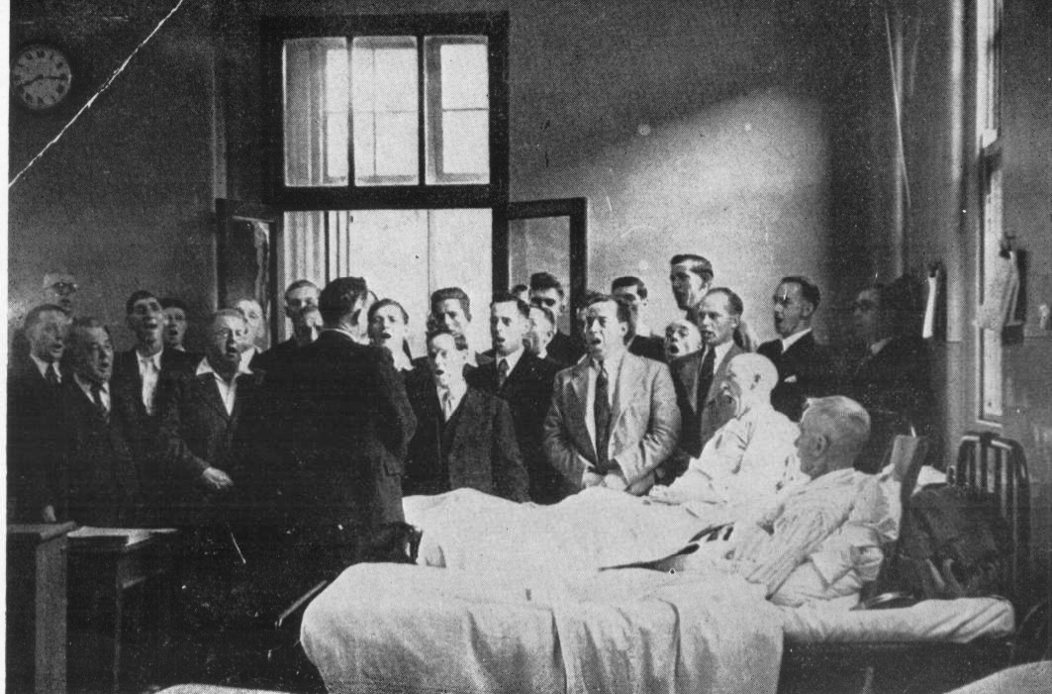

The minutes until 1950 contain the usual entries about festivals and concerts, tea dances and garden parties, more details of those festivals appear later in this publication. Preparations were now being made for the prestigious ‘Festival of Britain’ to be held in Huddersfield on June 6th 1951 and discussions had been made with the B. B. C. about traveling to their Leeds studios for an audition to record a broadcast, ‘Where they sing’. On 14th February 1951, Mr. F. Wade from the B. B. C. came to a rehearsal to review the choirs singing. He was suitably impressed by what he heard and arranged for the choir to record in the Central Hall, Thurnscoe, when the Times Production Recording company came along and recorded, ‘It Was A Lover’ by Dunhill, ‘The Silent Land’ by Woodgate, ‘There Be None Of Beauty’s Daughters’ by Gibbs, ‘The Wanderer’ by Elgar, ‘Let Us Be Merry’ another Dunhill piece, ‘The Old Woman’ by Roberton and ‘The Fighting Tameraire’ by Bantock. The broadcast went out from the Leeds studio’s of the North Home Service at 6:40 until 7:00pm on Friday 4th May 1951. The production company sent copies to the choir but sadly they seem to have disappeared. On Saturday 5th May, the very next day, it is recorded that at the Sheffield Eisteddfod, in the Victoria Hall, many of the members of the six competing choirs had heard the broadcast and congratulated the men on such a good programme. It is also recorded that the adjudicator must not have enjoyed it. The secretary Mr. L Williams wrote “We sang The Fighting Tameraire, which the choir sang exceptionally well. The adjudicator Mr. Edward Taylor who gave the most incompetent adjudication I have ever heard, placing us fourth out of six choirs”. I think that most, if not all competitors have thought that at some time or another. But we must all abide by the adjudicators final decision.
Mr. R Crockett and Mr. W Allinson were delegated to attend the Doncaster Urban District Council meeting on the Festival of Britain celebrations and afforded the power to commit the choir to whatever they felt was necessary. They came back with bookings for two concerts. With a payment of TEN POUNDS (£10.00) per concert, this was a near fortune in 1951, so I’m told.
The B B C had had 10 inch records pressed and offered the choir first opportunity to buy them. 50 copies were ordered at a cost of 6 shillings and 9 pence each. These recordings have also disappeared, unfortunately.

At a meeting held on 24th June 1951, a letter from Mr. I Hague, president of New Stubbin Male Voice Choir, inviting the choir to join the National Association of Choirs. A lengthy discussion was had and eventually it was ‘carried unanimously’ that the choir join the association but opt out’ of the music loan scheme. We are very proud to say that we are still members and have been ever since that time. On the 22nd July Mr. L Williams resigned as secretary to the choir, reasons were not recorded, but there were plenty of members wishing to step into the breach and a ballot was eventually held between Mr. R Crockett and Mr. J Caldron. Mr. R. Crockett won by 13 votes to 6 and continued the meeting by thanking Mr. Williams for his hard work over the last five and a half years. His first official duty was to appoint a contributions secretary. One week later he proposed a sub-committee to discuss and pre-select music festivals the choir should attend. This was as a result of complaints about lost rehearsal time. The conductor, his assistant, the secretary, Mr. L Williams and Mr. R Roper were chosen to undertake this task. The chairman resigned, (although no reason was recorded) and Mr. E Latham was appointed to the position.
On September 29th, a choir of 36 set off to Knaresborough sanatorium to entertain the patients and their guests. It is recorded that such was the success of the trip, “the choir enjoyed the food better than the patients did the singing”. Choirs have always liked a good feed and drink after a concert, in my experience.
In October of 1951, both the choir and octet entered the Mexborough Music Festival. Despite the octet being unable to rehearse together because of shift patterns, they had only rehearsed ‘Sleeping’ separately in their own parts, (T. T. B. B.) but made a very big impact on the adjudicator, who praised both the conductor and the singers, coming away with the first prize. It is then reported, that in November, the choir gave a concert in the South Parade Methodist Church, Thorne, Doncaster, when Miss Mary Wooten, “elocutionist, traveled with the choir and performed recitals and acting for the audience, as did Mr. M. Carver & Mr. J Caldron, (choir soloists) in their usual efficient manner”. One week later the choir entered the first Dearne & District music festival. They sang, ‘Dawn Among The Dead Men’ as a test piece and ‘How Sleep the Brave’ for their own choice. The adjudicators remarks are minuted as saying, “I think we owe this choir a debt of gratitude, because that lovely item was the final item of the festival, what an exceptional finale to this wonderful first Dearne & District music festival”. The conductor was then approached, in an attempt to persuade him to bring the choir to the forthcoming Mexborough music festival, “because you pull the crowds” he was informed “and we need to boost the funds”. Cheek of it, the choir had already registered for it anyway. An application to join the choir had been received from Mr. J Jones, the owner of the Thurnscoe Hotel, our home for many years. Yes, he was accepted.
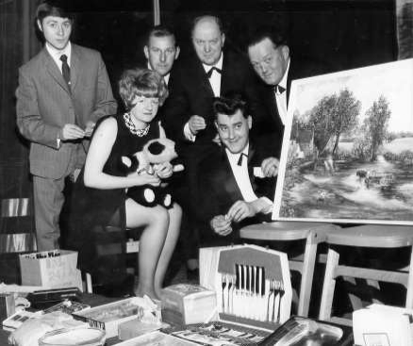
Left.
Members and wives help- ing with the Christmas raffle prizes. Circa 1951.

In early 1952, Mr. W Bullars went into hospital, having been ill for quite some time, so the lads en-bloc paid him a visit in Wath annex. They sang from 7:00 pm until 8:30 pm and he was delighted, as were the other patients. “Best tonic fo’ rum” was heard many times. As had now become the custom, the lads also had a collection for him and his family. A very generous £2:7 shillings was handed to him and his family. 4 days later, a contingent, 16 members, of the choir went along to entertain at the Thurnscoe old age pensioners retreat. A good two hours was spent amusing the guests and the members were treated to a fantastic buffet, mixing with the old folk and socialising for another hour or so. Further to their community spirit, in April, 21 members sang for the Barnburgh over sixties club, conducted by Mr. T Hulley, at the Ivanhoe public house, Doncaster.
4th May 52. A letter from the National Association of Choirs inviting delegates to Morecombe for the conference on Saturday 17th May. Mr T Hulley was to put a question to conference that reads; “Should the composers markings regarding tempo and dynamics be strictly adhered to by choirs performing works selected as test pieces for competitive singing”. A question I think every choir has asked, but no-one has had answered officially. Interpretation seems to be the general consensus.
The annual report 1952 welcomed the new members to join since the previous year's meeting and encourage them to keep up the momentum and enthusiasm they had already shown. In the year they had attended 8 music festivals, a total of three 1st prizes, three second, and two third prizes had been achieved. The secretary expressed great disappointed in the average turnout (for festivals) of 29 when 40+ were on the register for over 18 months. They had performed a total of 8 concerts with good audiences,
with average attendances reaching 35. Attendances at practices were reported to be improving, but it was impressed upon them that they must be more punctual. Everyone had expressed pleasure that the conductor was improving health wise and thanks to Assistant conductor, Mr T Hulley for taking over at short notice, leading us to more victories. Gratitude was steeped on Mr. R Roper for his efforts in raising funds. Not everybody was believed to be pulling their weight to help in this area, although the St. Ledger and Xmas draws were the biggest source of income, in excess of £60. The balance sheet was read with the income for the year being £332/14s/09d, expenditure £224/18/00½d with a balance of £107/16/8½ d.
At the Annual General Meeting on the 8th February 1953, they were pleased that their president, Mr C Fretwell was able to attend after his long absence due to work commitments and living out of the district for such a long time. As had happened now for a few years, the Officials were returned en-bloc, with their permission and an addition made to their ranks. A contributions secretary and a librarian were appointed at the proposal of Mr. Sydney Clark. A proposal was discussed and later passed unanimously that the scheduled tea dance should be cancelled in favour of a ‘bus trip’. Two attaché cases were to be purchased out of choir funds, one each for the secretary and the librarian and a music stand also to be purchased for the conductors use at concerts.
Doncaster Urban District council had approached the choir with respect to available dates and ideas for the June 1953 coronation celebrations, a meeting to discuss the area’s plans was to be held in the Welfare Hall, Goldthorpe, on Friday evening the 6th March at 7 p. m. Postcards were ordered to be sent to all members not present at this meeting to inform them of the items covered and asking for any ideas to be passed on. Unfortunately, the minutes for the next 12 months are not very revealing, only saying that the normal routine was followed and that there were five festivals entered, with three first prizes, one second and a third. What happened for the coronation? If anyone knows, please let me know. (I wasn’t even born yet!)

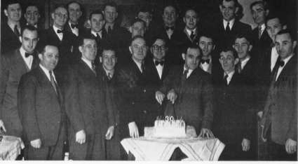

Officials and choir cutting their 30th anniversary cake.
On the 10th January 1954, at the Annual General Meeting, Mr. R Crocket, secretary, read his report for the past year (again, this was not very revealing) and finished with the following extract from that report. …. “On 24th September 1954, this choir will be celebrating its thirtieth birthday. Some of the founder members are still connected to the choir and to those men, for thirty years, some of them very lean years; this choir has been and continues to be one of their main interests in life. During these years the choir has earned a reputation that is the envy of many fine male voice choirs. A reputation for really fine singing, good sportsmanship and always being willing to help charitable, religious and other organisations. This reputation has not been gained by one man alone, but the choir as a whole, by each individual member realising his responsibilities, by a great deal of hard work and sacrifice by past and present members. The choir and its reputation are something we should all be proud of”.
It was reported that a credit balance for 1953 was £121/ 10s/ 11d. Disappointment was expressed at the loss of momentum with the weekly fundraising raffle, the St. Leger and Christmas draws. All members were encouraged to buy and sell as many tickets for all events as was possible so as to keep the choirs funding at an operational level. An official letter of thanks was sanctioned to be written to Mr. R Roper who had worked tirelessly to keep these funds going. The Officials were again voted in en-bloc with their approval, as were the grants, with the addition of the assistant conductor, Mr. T Hulley (£5) and the Librarian and chief fund raiser, Mr. R Roper (£5).
On Sunday 11th April 1954, the choir sang, by virtue of an invitation from the Reverend Harold Key, at a live service broadcast from St. Hilda’s Church, Thurnscoe East. This had caused quite a frenzied action of re-arranging a pre-booked concert in Broomhill church, but thanks to all concerned, with a little swapping and changing, everyone was accommodated.
At a meeting on 9th May, the secretary, Mr. R Crocket announced that due to the pressures of work, he could no longer continue to do justice to the role as secretary of the choir and gave two weeks' notice to quit the position.
At a meeting on the 16th May, the Treasurer, Mr. W Bullars resigned his position without explanation, but the secretary agreed to continue.

On the 30th May, one of the octets the choir had, were asked to audition for the B. B. C. with a view to making a recording for broadcast. Unfortunately there is no further information available as to where, when or whether this happened. At the next annual general meeting held on 23rd January 1955, a ‘members' sick fund’ was set up, only to last a few months before reverting back to the old system of having a collection for deserving cases. The system would collect 3d per week from members to form the fund and qualifying members were to receive a grant of £2 every six weeks whilst in qualification. An admirable gesture that proved far too complex to operate. In December of 1955, it was recommended that a member of the choir that had been ‘called up’ on national service, Mr. A Latham was serving in H. M. Forces abroad, (no indication of where) to be sent as a gift, 50 cigarettes. This was carried unanimously. On 15th January 1956, the annual general meeting was held and the report for 1955 was given. At this time the choir now had 40+ registered members. It was reported that the average turnout to festivals had been 33, whilst the concert average had only been 27. The balance sheet for 1955 was reported as having had an annual income of £245/17s5d, with expenditure of £129 and 1 shilling. This left a fairly healthy balance over the year of £116. 16s and 5d. It was stressed that the Officials of the choir were ‘ordinary working men’ the same as all the other members, everybody should ‘rally’ round them over the next twelve months to improve on last year's efforts. When the business of the meeting began, Mr. Hulley proposed ‘not to accept this year’s grant as he hadn’t conducted the choir at all’. All other grants and Officials were again returned unopposed
en-bloc. The syllabuses for the coming year’s festivals were discussed and an application for financial help was read and a donation made to the Dearne and District Music Festival. A letter of thanks was read from Mr. A Latham for the cigarettes gratefully received and wishing the choir all the best until his return from National service. Another tea social was discussed and arranged with entertainment to be organised for after the food. A lengthy discussion ensued about the dwindling membership and
it was resolved that Mr. E Latham was to visit all members in default at their homes to clarify their intentions. On 26th February, Mr E Latham reported that he had made all the visits to members and had received ‘many and varied reasons’ for the abstinence. A letter was read from the secretary of Stockton on Tees Music Festival, requesting the presence of the choir at the forthcoming event , ‘…. because whenever the Thurnscoe Harmonic Male Voice Choir attend this prestigious festival, the venues you sing at are always filled to capacity’. Permission had now been received from the Reverend Harold Kay to use the Central hall for the next tea social and Mr. J W Smith was voted to replace Mr. M Carver on the social committee.
On 28th April 1956, Mr. E A Evans tendered his resignation as conductor of the choir. This was entirely due to ill health and he asked that everybody should keep up the hard work and give his successor the same support that he had been afforded. A vote of thanks was expressed to him for all his hard work and sacrifice over the years and his resignation was reluctantly accepted.
It was then proposed by Mr. T Hulley and seconded by Mr. J Clarke, that an extraordinary meeting be called for 26th May. It was further resolved that all past and present members be written to and informed of the enormity of this meeting and inviting all comers to attend. Mr. T Hulley agreed to continue conducting the choir until the meeting.
Extraordinary General Meeting, 26th May 1956.
The meeting was brought to order at 6.45pm. Two ex-members had accepted the invitation to attend. A lengthy discussion was held and at its conclusion, the following were points were recorded in the minutes. Mr. T Hulley was accepted as the new conductor of the choir. It was then proposed by Mr. L Williams and seconded by Mr. J Jackson, that the choir purchase a suitable gift from the funds, organise a testimonial fund and a presentation concert in his honour. Mr. S Clarke proposed and Mr. T Hulley seconded that a clock be purchased and ‘suitably inscribed’. Mr. R Crocket and Mr. R Ward were to buy the clock and see to the inscription. The secretary, Mr. R Crocket was also asked to write to vice presidents and anyone that had connections with the choir to see if they wish to contribute in any way. The testimonial concert was to be scheduled for September 1956 when the testimonial fund would close and a presentation made to Mr. E A Smith at this time. The president, Mr. C Fretwell was chosen to present the clock. A concert was also arranged in the rehearsal rooms at the Thurnscoe Hotel, all proceeds to go to the testimonial fund.

Rumours had been rife around the village and had started spreading further afield that the choir was to disband due to the conductors reported resignation, the secretary announced. It was decided that he should issue a press release refuting the rumours, also mentioning the testimonial fund and that they were currently recruiting. All members were encouraged to pass on same by word of mouth.
It was also decided that they should go to the forthcoming Stockton on Tees music festival. The meeting was eventually closed at 8.30pm.
A letter had been received from the National Association of Choirs, a copy of which was kept on file that read:-

Dear Sir,
It is with regret that we learn of the resignation of your conductor, Mr. E A Smith. He has, as we all know, been associated with the Thurnscoe Harmonic Male Voice Choir for a good many years and though you are bound to miss his guiding hands, we hope the choir will continue to go forward from strength to strength, as a living tribute to the vast amount of work that Mr. E A Smith has put in over the previous years. He will, I’m sure, be there to assist whenever possible, and to give whoever takes his place the benefit of his knowledge. I am sure that all members of this association will join me in wishing Mr. E A Smith a long, happy and healthy retirement and in paying tribute to the work he has done for the art of choral music. His retirement is a loss, not only to his choir, but to choral music in general.
Yours sincerely Colin Hague Honorary Secretary.

The original copy of this letter was presented to Mr. E A Smith in a folder of such items at his testimonial concert. A Mr. Wilkinson had come along to listen to the choir and was very impressed and as a result, the B. B. C. had again asked about the choir recording another program for them called ‘Sing we and Chant it’. This was to be recorded on November 3rd 1956.

In December, permission was sort to fund raise around the local public houses. It was decided to make a start at 7.00pm at the Fairway. This was one of four venues chosen to carol sing for the locals to raise much needed funds for local charities. This was to be followed up after the Christmas break, from 23rd December until 6th January, with a free concert to be held in the local swimming baths for the pleasure of the local old folk's movement.
At a meeting on 6th January 1957, it was decided that, in addition to the choir entering this year's Harrogate festival, three quartets would also be entered. A request was received from Houghton Male Voice Choir to assist in singing at a concert to be held at Mill Lane Methodist Mission, South Kirby. This was agreed along with many other requests for both quartets and octets to entertain in various local churches.
At the Annual General Meeting held on 27th January 1957, the secretary’s report and the balance sheet were accepted then the officials and grants were passed en-bloc, with yet another addition to be paid to the contributions secretary of 3 guineas. A discussion ensued about the appointment of an assistant conductor. It was agreed that Miss M Smith, the ex-conductors daughter and choir accompanist was to take up the position, thus necessitating the need for an assistant accompanist. Mr. J Clennell was asked to see if his sister, who had played periodically for the choir, would be interested; also Mr. R Roper said he could have a possible candidate. Both were encouraged to make further enquiries. A series of children’s parties, tea socials and evening’s of entertainment for members and wives or lady friends were discussed and the social committee be given the go ahead to arrange these. Mr. A Latham was welcomed back into full membership following his return from his stint in H M Forces.
Although the choir had normally had an accountant check the accounts, Mr. Allinson and Mr. Pearson were thanked for checking them before going to be authenticated.
At a meeting on Sunday 3rd March 1957, after a relatively short discussion, it was proposed by Mr. R Roper and seconded by Mr. J Burkenshaw that Miss Irene Clennell be appointed assistant choir accompanist. The syllabuses for the year’s music festivals were discussed. A request had to reluctantly be denied for concerts, due to other commitments, and the arrangements for members to deliver the food donations towards the forthcoming tea social were reiterated. (It is later recorded that this had been a resounding success and Mr. E Latham was thanked for his hard work).
On the 10th March, Mr. E Sayles from the Dearne Amateur dramatics society visited the choir, requesting the member’s assistance in a production of ‘The Student Prince’. Members working in the coal industry that wanted to participate would have their shifts changed if necessary, and the sponsor’s, the Coal Industry Social Welfare Organisation, would pay them for rehearsal and performing. The choir later took a vote on this venture and a majority voted that the choir should not undertake this extra workload; votes were 17 against and only five for. A fee of £4 had been offered to perform a concert at a local hostelry, The Collinwood Hotel, Bolton on Dearne, and thus accepted. A request had been made by Crookhill Hall sanatorium for the choir to
attend and sing at their Garden party on 10th August, this was to raise funds for the sanatorium. Two more garden party applications, for Hooton Pagnal and Darfield, had been received but due to other commitments and holidays, they had to be denied. The BBC again approached the choir to record another program for them; the venue for recording changed a few times at
their request and finally was completed in the Festival Road School Hall, Wath upon Dearne, on September 28th. A pre-rehearsal was arranged for 6.pm at the Thurnscoe Hotel rehearsal room and transport laid on at 7.30 to convey the choir to Wath.
A letter was received from the matron of Crookhill Sanatorium, thanking the choir for helping to make the garden party a massive success and giving up their valuable free time to help those less fortunate than themselves. It was agreed that an octet or ensemble would be entered for the Mexborough music festival along with the choir as well as the Dearne and District music festival. Concerts in the welfare hall, Goldthorpe, on Friday and Saturday 15th & 16th November were arranged as part of the International Theatre week. Proceeds of the Saturday concert were donated to the ‘Barnburgh Colliery Disaster Fund’.
Mr. Steven Wilkinson of the BBC reported to the choir that the recording was a resounding success, one of the most memorable recordings he had been privileged to attend, that this recording would be used for the proposed new series of BBC programs called ‘Choir Night’.
At the AGM on 16th February 1958, Miss Irene Clennell was added to the list of Officials and received her first ever grant of £3, as assistant accompanist. Mr. T Hulley had expressed his intention to resign, but after a discussion he agreed to continue ‘pro tem’. He expressed great disappointment at the falling attendances with members on the books and his great disappointment at not being able to enter the Huddersfield Music Festival. Although he reaffirmed his total commitment to the choir, he made it clear that he would reassess his decision after the forthcoming National Coal Board, Barnsley Music Festival and concert. To rekindle the interest in the choir, the president offered to duplicate the meeting reports and post a copy to all members, old, new and lapsed, hopefully to inspire a renewed interest. The rehearsal times were adjusted on a Sunday to 11.30 until 1.pm in an attempt to encourage more members. Subscriptions and meetings were only to be dealt with either before or after rehearsal so as to maximise the singing time. Sadly, it is reported that in spite of every effort to rejuvenate the choir, the numbers were slowly dwindling.
In September 1958, Mr. T Hulley tendered his resignation, among the reasons recorded are the lack of support and his other passion, brass band music, to which he had committed himself to a concert every Saturday night. This had been a very long and difficult decision for him to make, consideration had been ongoing since the AGM. His resignation had been written in July, but only tendered in September. The choir had no choice other than to accept it, reluctantly, and immediately proposed that an extraordinary meeting be called for October 5th 1958.
At that meeting, it was agreed that the assistant conductor and accompanist Miss Mary Smith would take over as conductor and the assistant accompanist, Miss Irene Clennell, would become the accompanist. A position that she held as Mrs. Irene Hill, until she passed away.

Mary had the same insight and love of music as her father before her, but some say she didn’t have the same control over the men of the choir. She certainly started as she meant to continue with her first festival, at Matlock, gaining a first prize in the afternoon. The adjudicator proclaimed the choir winners by a very large margin and said that they had out classed all other entrants. At the evening event, when, contrary to Mary’s plea’s for abstinence, the choir had ample ‘refreshment’ inside them, the adjudicator remarked that he could not have envisaged an improvement from the afternoon performance, but had been ‘very pleasantly surprised’ by the “sweet and absolute magic” of that evenings singing.

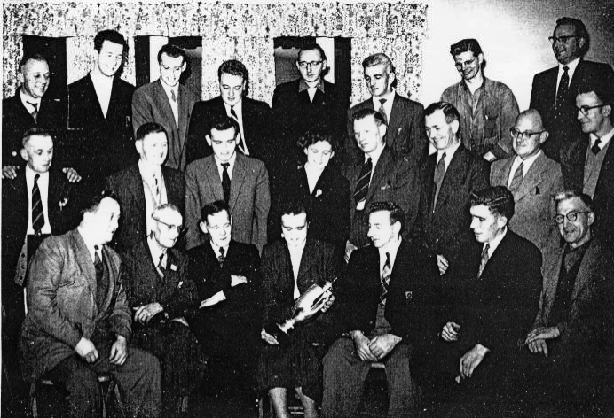
Mary and the choir admiring their hard fought and won trophies.
Of the thirty festival appearances during Mary's directorship of only 6 years, she steered the choir to placement in twenty-six. There were 11 first places, 4 second places, 7 third and 4 fourth placements.
This was an absolutely remarkable achievement for a lady in those days, in a predominantly male environment.
Mary left the choir in 1964 as membership dwindled.
A potential candidate for the position was approached by a few members left and asked him to come along and give it a try.
When Colin Leech attended his first meeting of the Thurnscoe Harmonic Male Voice Choir, in their rehearsal room at the Thurnscoe Inn, there were less than ten members present. After much scepticism, Colin was appointed musical director and thanks to his dedication and hard work, the choir numbers soon began to swell again. Although Colin was unlike any other before him, his unique interpretation, his poetic reading and explanation of every aspect of the music and words soon made him a very popular and inspired choice. Each song became a story to tell, with passion and verve. His number one rule, ‘never sing louder than beautiful’ became the standard. The choir soon caught on to his expectations and practiced just as passionately as they were being taught, and very soon they themselves were holding audiences absolutely spellbound from the very first word in a concert or festival item to the very last. Colin’s grasp of music soon transformed the choir into an ‘A’ class choir and together, with much hard work from all parties, they ensured that the rich and beautiful tone that has now become synonymous with the choir would be evident wherever they performed. This choir could not be beaten on the concert platform and proved very difficult to beat in competition. Yes, there have been choirs that have an d some still to this very day remember such victories with pride, the day they beat Thurnscoe. Under Colin’s great leadership, the choir have performed concerts country wide, they have traveled the length and breadth of our country and also, quite extensively internationally. Many venues have requested our services for fund raising and some just for the pleasure, time and time again, although sometimes the costs have been prohibitive, we have always made maximum effort and enjoyed doing so. As Colin is always willing to acknowledge, Irene Hill, our accompanist and long serving member of the choir has been his right hand, with her knowledge of music and flair, there have been times when she has held the choir together after a mishap during a performance and somehow she’s managed to play us back on track.

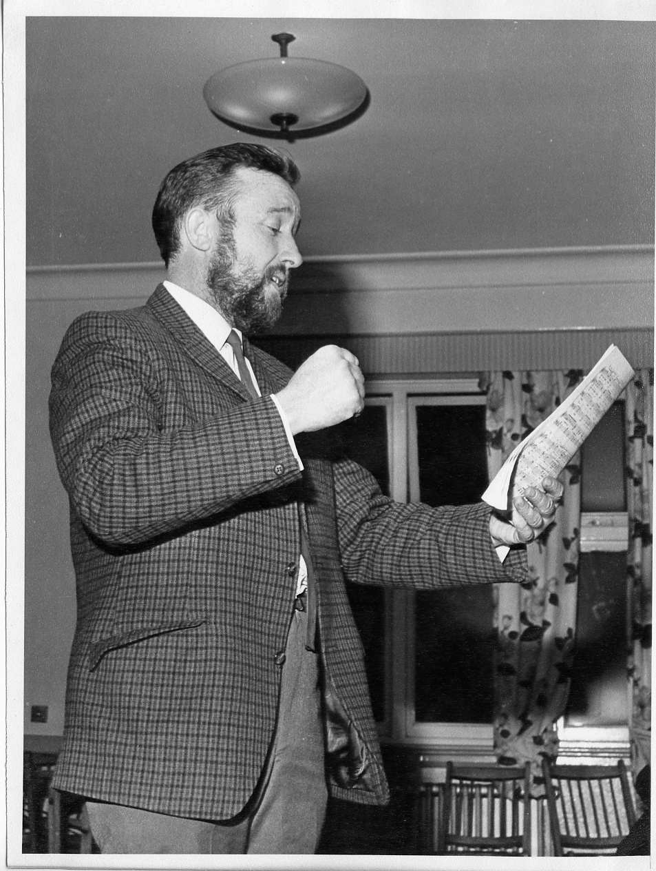
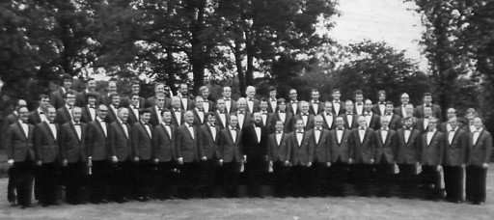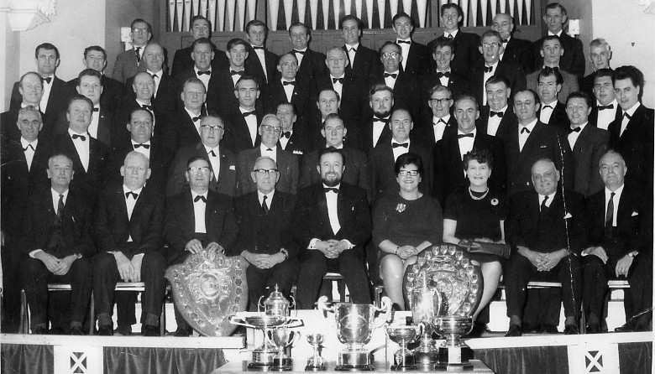
The 1974. Visit to Holland.
Among many features of the choirs jubilee year was a visit to Holland, proving in every respect to be a resounding success. Their first commitment was to make a recording at Radio Hilversum. Six items were recorded in the chapel at broadcasting house and were broadcast nationally later. They then were conveyed to their hotel in Velp, in preparation of the evening concert and dinner in Arnhem Town Hall, hosted by the local Provost and after an exchange of gifts, the concert was performed to a capacity audience. Sunday morning brought a concert in the grounds of the open air museum in Arnhem, at the invitation of the Enka choir, and their singing from the veranda was very warmly appreciated by the many hundreds of visitors. The hospitality and friendliness of the Dutch was second to none and afterwards they were conveyed to Oosterbeck where the graves of the victims of the ‘Battle of Arnhem’ are. An emotional visit to the British section saw members looking upon the graves of relatives and friends lost in the conflict, for the very first time. The choir placed a floral tribute on the memorial with a suitably inscribed card.
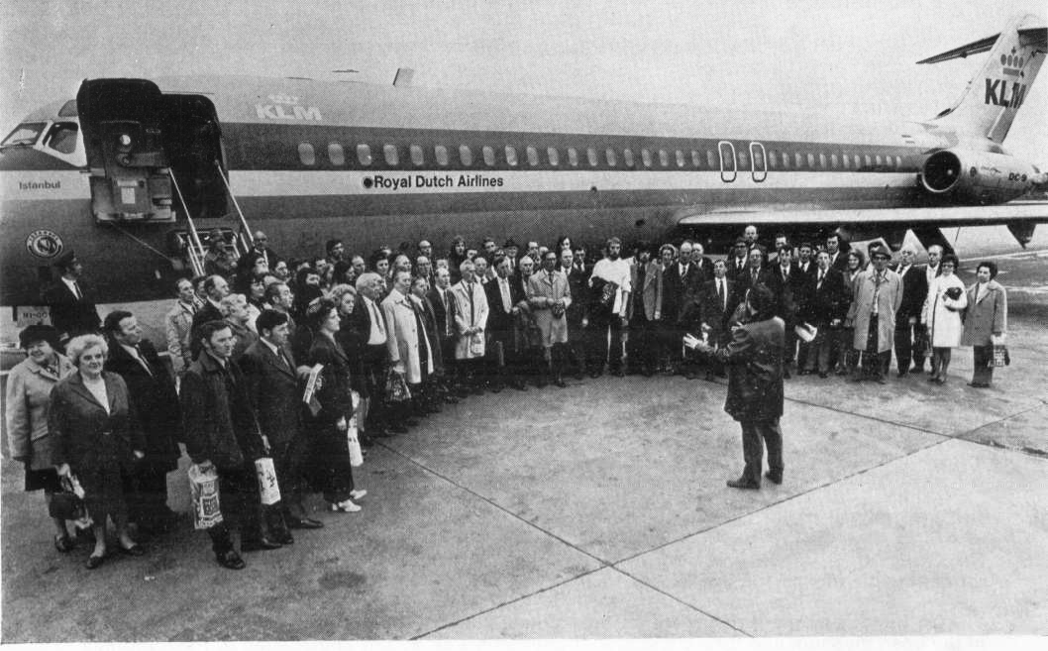
A two hour tour was taken on the canal systems of Amsterdam, some 60 or so miles away, and in true choral style the choir was very well received as they regaled their fellow sailors.

Left.
On the ‘tarmac’ at East Mid- land Airport, at the request of the air crew, singing, ‘Jacob’s Ladder’.

A memorable 1979.
On one of the choirs many pilgrimages to Llangollen, they were invited to perform in the evening gala concert and although their performance had not impressed the adjudicators in the competition in the daytime section of events, (being placed only ninth out of 18) they certainly made an impression in the evening.

Performing at their best, alongside the evening’s artistes was two from the U. S. A., from Poland, Belgium, Germany, Ireland and Sardinia, dancers from South Africa along with soloists from Wales and England. As this was International Year of the Child, there was a ceremony of massed children’s choirs from Denmark, U. S. A., Poland, Scotland, Northern and Republic of Ireland and England. Being second to perform after the half time interval, the audience were well and truly into the swing of things when Thurnscoe mounted the stage.
They performed ‘ She Walks in Beauty’ by Bantock first, receiving a heartfelt ovation for a few moments. Then they performed their ‘party piece’. ‘The Owl and the Pussycat’ by R. de Koven. This piece had been a favourite of the choir and their audiences for many years and still is. It’s the old poem by Edward Lear, set to music. When the choir perform this it is choreographed and a member (the late Sid Clarke’s role) puts on a plastic pigs nose with a ring in the end of it, parading round the stage pulling faces at the audience, whilst the rest swing and sway in time to the beat, at one point bumping into each other as they imply timing failure. The conductor keeps sustaining notes as we imply choking and everyone has a good time. Upon the completion of the piece, that massive tented area with approximately 5000 capacity audience were totally silent for a couple of seconds, totally bemused by what they had just witnessed.
Never before had most seen a male voice choir break so many rules in one performance. Then, simultaneously the audience went wild. They stood applauding, throwing cushions in the air, whistling and calling for more for a full fifteen minutes. Colin Leech later reflected that the officials and adjudicators of the weeklong event didn’t look too impressed, but this was for the audience and they loved it. Of the fourteen performing acts on that Saturday evening, 7th July 1979, the memories are vastly in favour of this one choir performance.

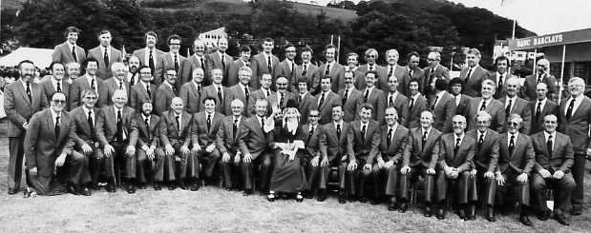
Left.
60 plus strong choir at the Llangollen Music Festival.
Circa 1980.

1980.
One of the most outstanding memories for the choir was at the Llangollen International Music Eisteddfod on Saturday 12 July. Three pieces were sung by each choir, ‘Hey, Nonny No’, ‘Pueri Hebraeorum’ and an own choice of the competing choirs home nationality. South African, Polish, German, Greek, Italian, Czechoslovakian, Argentinean, Welsh, Irish and English choirs lined up to take their turn at impressing the adjudicators. The Greek choir came first with 267 points out of possible 300, Thurnscoe were 2nd with 265 and the Czechoslovakians came third with 263. To attain this position against such strong international competition was an absolute delight to everyone connected with the choir and people who attended on the day, whether competing or guests still remember it with great warmth. There was a lot of local press coverage of this event in Barnsley and Rotherham following this achievement and I was made aware that two members of the choir worked at the same place as myself, Yorkshire Traction Company, had connections to the choir, both bus drivers. Mr. M. Hallet was a top tenor and Mr. B. Westgarth's auntie had been the conductor of the choir for 6 years, steering them to many placements in prestigious competitions. In 1983 I was fortunate enough to see the choir at St Mary's Church in Wombwell under the direction of Mr. C. Leech and asked if I could join the choir. He encouraged me to attend a rehearsal in Thurnscoe and the rest is history.
1984.
My first competition experience was at the Blackpool Music Festival. From memory we sang ‘She walks in Beauty’ and ‘Hey Noni No’. The sheer excitement, apprehension and nervousness as I walked onto that Winter Gardens stage, with what seemed to me at the time, its vast auditorium, with the lads. I was shaking with fear until the piano sounded its first note, then the beauty of the music I had been taught, totally engulfed me and nothing mattered to me except to give those assembled the privilege of hearing what the great Colin Leech had taught us about these two contrasting piece’s, in his poetic and emotive way. The applause after the first item seemed to be endless and sneaking a quick look out into the audience, I could see people stood, applauding, cheering, and shouting for more. I couldn’t believe it, even our peers that had already sung their entries were on their feet. Then we sang our second item to perfect silence, after which we received more of the same. My every muscle was tingling; I had never experienced such complete and utter elation. I had been with the choir for only one year and was very privileged to be part of such an occasion.
When it came time for the adjudication, it soon became clear that they had also enjoyed the performance. The adjudicator said “one word to describe that performance gentlemen, it was a GEM”.
1989.
We were approached on behalf of 'Yorkshire Television' to make a 45 minute documentary about 'The Thurnscoe Sound', the village of Thurnscoe and the closure of the colliery. It was filmed early in the year culminating in the demolition of the 'head gear' (the winding wheel for the lift or cage as it was known). This is now available on YouTube. Look for 'Thurnscoe Sound'.
In November 1989 the choir set off on the journey to the First International Malta Music Festival. The officials of the time had worked tirelessly in the detail of transporting and facilitating every requirement of the trip.
Early, one cold frosty November morning, five coaches began picking up the 100 members, wives and guests for the long haul to Saint George’s Bay, Malta. By design, my family and I were last pick up on our outbound journey to East Midland airport. At the time, with three children to supervise, Paul 4, Samantha 3 and Stacey only eighteen months, this was foreseen as going to be a real ordeal. Members and guests alike soon dispersed any doubts in our minds about the wisdom of this decision. From stepping out of the house, with suitcases, pushchair, children, hand luggage etc; etc; etc; help was in abundance, for which we shall be eternally grateful. After boarding the flight, occupying all except one seat on the aircraft, members and their wives took turns in entertaining the three young ones and four hours later, after singing a couple of songs, at the request of the flight crew, just before landing in Laqua airport, we managed to retrieve them.
Upon arriving at the hotel complex, late because the coach we had travelled on, dropped off at every little place on its journey, whereas, most of our party had travelled direct, our room had been issued to another guest. The kind people overheard my protests to the management and kindly returned the keys to the desk so we could sort out the children.
The organisation of the festival was very good, coaches complete with tour guide were provided for all participants, in our case, three coaches with guides, the itineraries of which were very varied and encompassed almost all the attractions possible on Malta and Gozo.
The competition itself had a commissioned piece, ‘Pacem in Maribus’ as the main test piece with a 20 minute programme of own choice to express the choirs concert ability. Our own choices were 'The Last Words of David', 'Cavatina', 'She Walks in Beauty', 'Music of the Night', 'Dana Dana', 'Do You Remember An Inn Miranda' and 'Tydi A Rhoddaist'. Points were awarded at 50% for the test piece and 50% for the concert programme. On our first and only appearance at the festival held in a local university hall, we found that, sadly, the preparations for the heats had not been to the same standard as the rest of the stay. We were up against very stiff opposition, semi professionals and university music students, but we gave of our best. In perfect keeping with adjudications, on this occasion we did feel rather less than pleased, but accepted it. We didn’t compete in any further heats but went on to thoroughly enjoy a wonderful stay.
We were invited to attend a communion service at the Anglican church of St. Paul’s in Valletta and afterwards entertained in the undercroft below the church. As I recall, we sang the Chorus of the Hebrew slaves, (Speed your Journey), Tydi A Rhodyst, Take me Home and one or two more. We were offered wine and sandwiches and had a very pleasant couple of hours with the parishioners.
On one day trip organised for us we performed an impromptu concert in Gozo’s capital market square in Victoria (Rabat) and received a wonderful reception. Locals stood listening and applauding from their little balconies. Tourist’s gathered to listen and all had such a wonderful experience. On our return ferry journey to Malta that day we were again asked to perform a couple of numbers, which we willingly did.
On the departure day we were informed that a cargo aircraft had crash landed and blocked the only runway at the airport, (the old airport now) resulting in a delay of 12 hours. During this period, a large section of the choir, along with the three youngest in the party decided to take advantage of the pleasant climate and outdoor swimming pool. The children never felt the cold, but believe me, their father did. Again, the powers that be, made provision for every need and we returned to East Midlands at a reasonable hour and then on home.
In 1990 we decided not to return for this festival, but in 1991 we attended the 3rd Int. Music Festival.
In 1990, among the many concerts we had agreed to we did a fundraising concert for the Scouts, to send two members of the 23rd Barnsley (Thurnscoe) scout pack to the World Scout Jamboree in Seoul in 1991. There was also a massed male voice concert in the Metrodome, Barnsley, a fund raising event for the Children's Society at Sprotborough Richmond Hill School and yet another visit to Ely, Cambridgeshire, at the wonderful Malting Centre, to help fundraise for a local hospice.
On September 21st, 22nd and 23rd July 1994, members of the choir took part in, singing and acting, 'The Dearne Opera', a production about the 1942 Barnburgh mining disaster. This was also filmed, recorded and televised. The choir also travelled to Stanley, Durham for a competition and chose 'The Voice of the Child' to sing, by Geoff Richards. The original adjudicator had been ill and could not attend and the organisers found someone to take his place. We were not aware until we arrived on stage to perform, it was Geoff Richards. He sat back and listened and when it came to his adjudication, he said, "When I wrote that song gentlemen, I couldn't have wished for a better interpretation", and thanked Colin Leech profusely. Later that year were invited to the Scarborough Theater to raise funds for McMillan's nurses.
A venue to record the new 75th anniversary CD had been suggested as Wentworth Church. Chris Thorpe of Serendipity, the company awarded the project, had suggested this, and after a long hard battle, the arrangements were made. This recording was done and the name chosen was to be ’75 Years of Song’. Although it was only July, it was suggested that the programme for the annual Christmas concert at Priory Place, Doncaster be decided soon so as to have plenty of time to rehearse the material. It was announced that we had raised £961, at a local charity open air concert, in aid of Saint Peter’s Hospice, Barnsley and had agreed to submit a cheque for £1,000. At this time, our stage carrying trailer needed extensive repairs and refurbishment. It turned out to be a very costly exercise and for a period a van was hired from a local dealer to ferry the staging to and from venues. This meant transferring it from the trailer to the van, to the venue to be used and returned to the trailer upon our return, a time consuming and laborious task.
An application had been made for the choir to sing at a private wedding for a very generous fee. Although this privilege was normally reserved for members and their families, the choir voted with a large majority that this could potentially become a good source of income and thus to honour the proceedings at the Hazelwood Castle Hotel. A selection of suitable material was recorded and sent to the family to choose two or three items of their choice for the big day. As the new millennium approached, so the requests to attend various functions mounted. Six more different concerts were arranged, in addition to our usual annual concerts and the charity ‘2000 in 2000’ millennium concert in Manchester. (This was also in aid of a Hospice). On 25th March 2000 we joined many other choirs, between 50 & 60, in a Millennium fundraising concert in Manchester’s Nynex complex. At rehearsals in the afternoon of the concert, Nigel Ogden, (BBC Radio 2 The Organist entertains) and a 72 strong orchestra all came together for the first time. The choir finished their respective pieces and when the orchestra came out to tune up and rehearse, they asked for an ‘A’. In a hilarious simultaneous response the 2,000 strong choristers began mimicking the orchestra by ‘tuning their throats’. A gesture appreciated by the members of the orchestra. In the evening, the 3 – 4,000 strong audience was very appreciative of the diverse and eclectic variety of music. I was very proud to have been present on that occasion and enjoyed my first accompaniment by such a wonderful orchestra.
8th August 1999. We decided that it was again time to make another recording to boost funds, as well as to celebrate our 75th anniversary years and there had been requests from our audiences for items to record. The music had now been chosen for the new recording. All items requiring polishing up to be left to the musical director’s discretion, but rehearsal should start soonest.
A letter of thanks had been received from St Peter’s Hospice, Gawber, Barnsley, (Barnsley Hospice) for the ‘wonderful open air concert’, performed with the South Yorkshire Police Band, informing us that the open air evening extravaganza had eventually raised in excess of £2000 for the organisation.
A free concert had been agreed at Wentworth church, opening their first music festival week, in response to them not charging the choir for using it for the recording. A festival that we have been proud to attend ever since, annually.
September brought confirmation that the Remembrance concert we had agreed to perform with a brass band, in the Lamproom Theatre, Barnsley was to be run along the lines of the annual televised version from London. We dug out quite a few of the old war songs and camaraderie type songs that were really appreciated by the Legionnaires at the event. We also accepted an invitation to sing at a local retail park, in the run up to Christmas, entertaining customers and were allowed to collect for local charities. Biddulph festival committee had approached us about a massed choir concert for their anniversary year instead of a festival. This joint venture gave approximately 20 minutes to each choir, guest soloists, as well as joint items and audience participation. This we did attend and Biddulph committee organised a really fantastic evening, with their usual competence.
A booklet was produced by Eric Hill for the 75th anniversary and after a few logistical problems this was sorted and published.
Several of the choir member’s wives and partners reformed a ‘Ladies section’ to organise and raise funds for all sorts of beneficiaries. They organised several evenings’ entertainment, beetle drives and talent evenings that turned out to be very successful, raising large amounts for other functions. They even did catering when asked for the refreshments at concerts and visiting choirs teas.

In May 2000, due to the failing health of our president, Mr George Johnson and his wife, he had decided to resign. George gave full commitment to this choir all his years in his various other official capacities as well as just a member, and he expected the same from everyone else. He finally lost his gallant fight on 24th June 2002. A sad loss to a choir that he loved and who loved him.
Another devastating blow came on July16th with the sad death of another stalwart of the choir, Mr Francis (Mac) McGrevy. He was a long serving member who gave maximum effort all the time along with his son and, at one time, his grandson as well.
In April 2002 we were invited to entertain a civic dinner at Carlton Towers near Goole. Although the performance times were to be from 10 pm until 11.30 pm, after their Christmas dinner itself, a good turnout of members and wives, also invited to attend, was made and a very generous fee was accepted along with coach expenses.
Over the past years we have sung in some really wonderful places for some really deserving causes and therefore decided that we would again arrange concerts at many of those favourite venues and produced yet another compact disc from live recordings, for our 80th anniversary.
In early May the choir was invited and attended the Cornwall International Male Voice Choral Festival. The choir had decided to make a weekend of it and stayed at a hotel in Newquay. On Saturday we travelled to nearby Truro, to the Hall for Cornwall, to attend the competition. From the moment the advance party arrived for a briefing until we left the area in the evening, the organisation was brilliant. Everything seemed to be thought of and at times we were running ‘early’ and had to slow down and take a break. Full marks must be given to the organisers and the fellow choristers that became stewards for the day. They did a first class job.
The twelve competing choirs were ushered and chaperoned to every position, in order and with minimum fuss, then into that beautiful auditorium to perform to the vast audience and adjudicators. The quality of entrant on the day was second to none and the adjudicators had a really difficult task making their decision, however there was one choir, Revalia Male Chamber Choir from Estonia, which really was excellent. Consisting of 26 young men between the ages of 21 and 26, they were all music students with degrees. They truly deserved first prize with 95 marks (out of 100). 2nd came a Slovenian choir and joint third an ensemble from The Netherlands and a choir from the Faroe Islands. Joint 4th were St Peter’s MVC from Drogheda, Eire and The Harmony Men from Jersey. We attained 5th place. It should be said that every choir on that Saturday in this wonderful, exciting competition, no choir or member let themselves or anyone else down. All performances were memorable as were the entire day’s events.
The rest of the weekend was spent in the usual time honoured way of touring, site seeing and a really memorable day out at the spectacular Eden project.
Later in the year we were invited to join Dodworth MVC in celebrating their 50th anniversary year, with a choral workshop and evening concert. Workshops were held by Alan Simmons and Simon Hunt and an evening concert, with six participating choirs and compared by Jane Bennett Powell. During the workshop, on 22nd November, which clashed with the rugby world cup final, television had been organised to keep us abreast of the live coverage of the event. When the final whistle blew and the result announced, the whole of the assembled company burst into the best, most rousing version of ‘Swing low, sweet chariot’ I have ever heard. The evening concert went almost according to plan with the exception of our chairman, having been determined to attend despite not being in the best of health collapsed halfway through the choir's rendition of ‘Italian Salad’. He was very hastily and professionally attended to and we performed it again. I’m pleased to say that David did soon recover.
We were also invited to the 'Grand opening' of the Barnsley, Stairfoot B & Q store and performed on a stage to invited guests and staff.
In 2004, Mr. E. W. Hill, a long serving member of the choir and who had served as secretary and treasurer for many years, at times serving as both at the same time, passed away and the choir commissioned a piece of music for the choir to sing at his memorial concert. Mr. A. Simmons composed the music and words and on June 4th 2005 the choir sang the song, 'Radar' at his concert. All monies collected on the night were donated to 'Doncaster Air Ambulance'.
As a result of Eric's sad passing, Mr. J. Dugdale was made temporary treasurer and Mr. J. Keating temporary secretary and both were sanctioned into the posts at the 2004 A G M.
We celebrated our 80th anniversary with a special dinner dance in late 2004 and Mr. P. Mallender resigned as concert secretary due to poor health. Mr. A. W. Jermy, a long term member and committee member took over temporarily and was accepted as concert secretary at the following A G M.
It had always been the dream of Eric Hill to design and publish a website for the choir, considering his background and work within the IT industry. Mr. J. Keating, the new secretary was asked if he could look into this to try and bring it to fruition. He managed to get help from a member of another choir and was given basic instruction to design and implement a choir website. He took the job on and the site is still available, www.thurnscoe-hmvc.com , and the sight has been very helpful to members and the public. A computer was purchased for this use.
The choir was approached to sing a song by a local author, written to accompany his new fictional book, based on fact, about the mining community. It was called 'Yorkshire Is My Home' and was first performed at Brodsworth Hall, Doncaster on 1st August 2004 with a brass band accompaniment and has been performed many times to great effect.
In early 2007 Mr. C. Leech, our musical director and conductor became quite ill and Mr. P. Snipe, chairman at this time, having had his own brass ensemble and therefore some experience conducting, took over as deputy conductor in the hope that Colin would regain his health and return as soon as he was able. Peter was sent on an available conductor's course to help him convert from brass band conducting to choral conducting which had been offered to him at choir expense. Upon his return he thanked the choir and said he had found it invaluable and a great help. Members did, over the next few months, voiced their opinions that it had made a big difference and Peter went from strength to strength.
In early 2008, Mr. Colin Leech, conductor and M D of the choir for 45 years sadly passed away.
This prompted Mr. P. Snipe to evaluate his position of deputy M D and as his health was not the best, he offered his resignation to the choir as deputy M D although he would enjoy returning to his beloved bass section as a singing member.
Rumors following Colin's death were both local and widespread that the THMVC were going to disband and close. At an emergency general meeting held in 6th February 2008, members voted unanimously to continue and also to dispel any such rumors. Articles were published in three local newspapers stating this and advertising for a prospective new M D and new members. We were inundated with help from our friends in choirs and from members of the National Association we belonged to but none would be available full time due to other commitments. Advertisements were distributed to schools, universities and all the professional choral publications and organisations in the choral world. As there had been 12,000 visitors to our website in January alone, mainly due to information about Colin Leech, we also displayed tributes to him and requests for interested parties for the M D position.
A memorial concert was arranged and performed for Colin and as his wishes were to donate all proceeds to Barnsley Hospice. All 'his' choirs took part in joint, mass and individual pieces. The Thurnscoe Harmonic, Retford Male Voice, Horbury Ladies and Wombwell Senior Citizens choirs all took part. The concert was recorded and a double C D produced raising, initially, £5,000 which was boosted with further sales of the C D's.
It was around this time, June 2008, we were 'locked out' of our rehearsal rooms. Successive managers of this pub the choir had rehearsed in for over fifty years had walked out overnight. We were very fortunate to have contacts in the adjacent Thurnscoe Methodist Chapel, also used for community projects, so we transferred 6 6ft x 4ft x3ft music copy store cupboards and the upright piano next door and took up rehearsing there. Our music library boasted over 835 items, from opera to comedy to sacred and spirituals, totaling over 29,000 music copies at that time. This building had now been named as 'The Hope Centre' and only had a small chapel for devotion.
As there had been no progress obtaining an M D for the choir, in August 2008, Peter Snipe applied for the position which was granted. This position Peter held until he retired in December of 2009. His deputy of the time was asked to fill the position for the time being and consider taking over as Musical Director. Mr. Anthony William Jermy took up the mantel in January of 2010, confirmed and approved at the A G M that year. A position he still holds at the time of writing this.
Again, the choir was thrown into turmoil when a 'letter to quit' was received in August 2010. It seemed that the area Methodist Church circuit wanted to sell the building. After extensive searching around Thurnscoe for possible rehearsal premises, we could not find suitable space with either storage space or suitable ground floor rehearsal area, as requested by members less able to negotiate lots of stairs. We were invited to look at Goldthorpe Church Hall, about 2 miles from Thurnscoe, which turned out to be suitable in all respects, and where we remain to this day. When the choir was consulted, although thinking it would be a good ideal site, they stipulated that the name 'Thurnscoe Harmonic Male Voice Choir' should always remain, as written in the rule book. This is the choir's Prime Rule made on 24th September 1924.
It was a little late in the year to arrange a full Christmas concert in our hosts' church, St John and St Mary Magdalene, but the local police and church wardens requested we sing for the local old folk on Wednesday 15th December at 5 o'clock. Every year since then we have performed a Christmas concert in the church for our good friends.
As we had now been singing at weddings, when requested, we invited our latest bride and groom to our rehearsals to hear and choose their songs for the ceremony, as is the norm. We will consider almost anything, if we can obtain 'a copy'. We adapt our performance as required and along with entertaining the congregation before the bride arrives, boosting the hymns and singing during the signing of the register, Leanne requested we learn and sing 'Bring Me Sunshine', the old Morecombe and Wise song, which the congregation joined in with whilst the bride and groom danced up the aisle.
In August 2011, the choir was contacted by the niece of a founder member, Mr. J. Glover, who joined the Royal Air Force during the 2nd World War, was shot down over Brest and was sadly killed, requesting copies of the 80th Anniversary Year book and copies of all our recorded music.
Over the next few years, membership declined and again rose and little happened beyond the normal busy concert schedule and preparations were again being made for the choirs' 90th anniversary.
New Grey suits were purchased in time for our anniversary dinner and concerts. These were referred to as our 'Birthday Suits' by some members.
In January 2015, Mr. Bryn Jones, having already served on the committee, a term as concert secretary and as a very accomplished event organiser, became chairman, due to the resignation of Mr. Steve Ellis for health reasons. Steve had been very active in everything community based and had served the choir with great enthusiasm. Due to the sad passing of our assistant accompanist, Betty Heatley, long serving member, Cal Mason, a very good pianist and accompanist was asked to help out when required when Irene was unwell or unavailable. This he agreed to.
The choir had been asked to sing at the Barnsley Mayoral Inaugural ceremony as this year, Mr. Brian Mather a long serving member of the choir would be Mayor. We had attended a few of these by request and had sung at two other members Mayoral ceremonies, for Mr. Terry Gibbs, a member since 1985 and treasurer for many years, at both of his ceremonies and also for his charitable fund.

In 2015 the choir, along with Barnburgh Village Singers, a brilliant local ladies choir, travelled to Belfast, Northern Ireland to sing in concert for our long standing friends, The Donaghadee Male Voice Choir. During the weekend, we were privileged to sing in the parliament buildings, Stormont and a concert in the old Crumlin Road, Goal, (jail) that is now a museum. Saturday evening we performed as individual choirs and as a massed choir to a packed Belfast City Hall. Sadly, Mr. Robert Wilson M.B.E., their Musical Director passed away a week after the event. A delegation from both choirs attended his funeral.
After extensive negotiations, Mr. Stephen Carey, accompanist to Retford male voice choir for many years, second tenor and a very accomplished organist agreed to become the choir assistant accompanist, but because of other commitments, could only attend on our Wednesday evening rehearsals and concerts as and when available. Shortly after this, the Retford M V C closed down.
Another proud event for the choir in 2016 was a concert in the Marble Salon, Wentworth Woodhouse, and the largest in the country with 300 rooms over five floors and a grade 1 listed building. It was packed with dignitaries and guests to capacity, all in aid of the restoration fund. A similar concert was held the following year. A Christmas concert was also performed in December 2018.
At the A G M in 2017, Mr. Alan Pepper who had been a very good publicity officer to the choir became concert secretary, a role he undertook with real enthusiasm and competence and Mr. Peter Felton became chairman. As our president, Mr. Fred Brady was in very poor health a vice president was considered to take up the position. Mr. Michael McGrevy, with over 50 year's service with the choir was unanimously voted to the position. Fred passed away two month later and Michael assumed the president's office, at the request of the membership. This was later sanctioned at the following AGM. Mr. Peter Nye, 38 year veteran member had passed away recently and his widow made a donation to the choir to be used as we thought suitable. Bespoke folders were chosen and purchased with this kind donation.
We had been requested to sing at Harlow Carr R H S Gardens in Harrogate on the August Bank holiday. Although members were concerned about doing open air concerts due to the sound not carrying, as had happened on many occasion at events before, so it was agreed to research electronic sound devices. This was purchased, tested and taken with us on the day. The expense was considered to be well worth it. A wonderful time was had by all and the gardens reported record takings for the day with over 400 visitors, picnicking on the lawn in front of the choir, young children dancing and hundreds on deck chairs. We have been invited back every year it has been open since then.
On Thursday 27th September 2018, a service to celebrate the centenary of the Victoria Cross posthumously awarded to Tommy Jackson, a local man was attended, both at a service in St. Margaret's Church and at Swinton Cenotaph. We were also very privileged to be asked to attend and sing at the 100th birthday of Thomas (Tom) Hicks. A war veteran, who served in Sicily and was one of the first parachute engineers to be dropped in at Arnhem, was captured and spent the rest of the war in a prisoner of war camp.
In December 2019 were we asked to do a Christmas concert with a local school choir, age 8 to 11. This turned out to be an outstanding event with a capacity audience and as well as singing as individual choirs we performed together. This is where we were given the affectionate name, 'The Granddads' choir' by the young choristers.
On March 15th 2020, a 'Special Meeting' was called because of the concern among members about Covid 19. It was decided that "The choir should suspend all choir functions until further notice and the committee monitor the situation and confer on further action, then contact members when and if necessary."
The committee decided that to keep members informed and make sure members were keeping as well as they could, the 'Emergency Telephone list' was put into use with every member being called for a chat at least once a week. This list had been devised and in operation for many years and used to inform members of issues in an emergency. All the committee were keeping up with the latest information from government and N H S sites and after conferring, were to inform the members on their emergency list (5 or 6 members each) of the ongoing situation and the choirs position in relations to this.
In May, our concert secretary, Ken Barry, having much experience in communication, suggested that we try a video conference call for a committee meeting, although at that time not all (or many) had a clue what he was suggesting. After the success of this first meeting on May 24th, all the committee were instructed in the use of 'Zoom' conference calling and we tried to get all members into the idea of joining in a meeting and after some coaching and cajoling, we managed to get up to 30 members of the then 42 members, all plumbed in (with a lot of help from some wives, children and grandchildren) and we started having a weekly 'rehearsal' on a Wednesday evening, normal rehearsal time and day, although it was extended to 7 - 9 pm after purchasing a license from Zoom. Due to the limitations to the sound, all were muted except our musical director who was transmitting our accompanist ,who did not have a computer, via a telephone call and a loud speaker. Not the best rehearsal experience but it kept us going during lock down when nobody was allowed to meet.
We also introduced a 'practice page' on the website, so members wishing to get extra time rehearsing.
This did take a lot of organising as we needed to access our rehearsal rooms where we secured our electronic piano, organise the music director, accompanist and there were two officials to help assemble it and transfer the recorded songs to USB for transfer to the website and each 'song' consisted of 5 recordings. There was one for each of the four sections and then the accompaniment. Music copies were posted to members as were the meeting minutes so those without an email facility would get the same information as everyone else. Eventually we got this sorted and discovered a whole new way to get extra tuition. We also made ALL the choirs recordings available to listen to via our website so they could keep conversant with them.
In September we were informed that a long serving member and occasional accompanist to the choir, Mr. Cal Mason had passed away from an industrial illness contracted in one of his earlier occupations. Due to the restrictions on groups gathering, we could not honour him with the usual singing at his funeral, a honour reserved for members and their families, so we decided to attend the funeral and form a guard of honour outside the crematorium when he arrived.
In early 2021, the B B C contacted the choir to see how we were keeping the choir together during lockdown. The producer organised a Zoom meeting for members to give detail. This was televised on the later early evening and late night news bulletins. The choir had been involved in many television and radio programmes, interviews and performances over the years and it was deemed useful at this time to inform our audiences, both near and far, that even in these highly trying times, the choir were as determined as ever to continue performing long into the future.
It was in May 2021 that restrictions were lifted a little, but enough for the choir to consider 'open air rehearsals'. We were very fortunate to have two members with sufficient land to accommodate this and both, Mr. Michael McGrey, our president with 57 years' service and Mr. Peter Brookes with 9 years' service offered the use of their land. As the piano is electric, both made provision for it to be under cover and out of any wind, also, 'facilities' for members to use as necessary. We used Michael's on a Sunday until the evenings got lighter and warmer and Peter's earlier on a Wednesday, 1 pm until 3 pm. Both asked members to bring a garden chair to use as they were limited. Although all members attending these events, up to 30 members, sometime the locals joined in with their grass cutting and trimming. This brought a lot of much needed humour, to the delight of the members. During these rehearsals we had been rehearsing for our annual R H S Garden, Harlow Carr concert that was scheduled for the August bank holiday, restrictions permitting. being an open air concert it turned out to be a fantastic day out and concert with a great audience of about 300 or so members of the public, many congratulating us on such a wonderful performance after being 'locked down' for so long.
On July 21st 2021, we were given permission to resume our normal indoor rehearsals, with some conditions. Most members attended the first few with trepidation and very soon, health permitting, the full choir was enjoying getting back to what we love to do. We were very lucky and all but one member of the choir eventually returned. Sadly, Mr. Alan Crow, resigned due to personal mobility issues, unrelated to the pandemic.
During lockdown, the committee and officials of the choir worked together very intensely, possibly more than usual, to keep members interested, happy and any help that was needed was available, if requested.
Now we were able to return to our normal routine, things were again very intense, organising concerts and rehearsing. We again performed for many of our 'regulars', with 5 concert performances up to the end of the year. September saw us at St Margerates Church in Swinton, Mexborough for a parade and rededication of the war memorial. Afterwards we sang for an hour in the church for those attending the fundraising fair. We were asked to perform 4 more concerts during the rest of this year, one of which was the annual Brampton Beirlow senior citizens afternoon gathering put on by the parish council, proceeds for the Royal British Legion.
By chance, the lockdown experience had taught us some interesting and valuable ways for better preparing the choir for unforeseen events. One very important and helpful tool was using our electronic keyboard in many different and useful ways. We started recording on the internal memory and transferring them to U S B for saving on our computer files so in the event that we got stuck without an accompanist due to illness, we could utilise these recordings. As with many male voice choirs today, the average age is quite high and although there are many competent with technology, electric musical pianos and equipment aren't the normal interest for us. As long as we have a competent accompanist to play, we're happy. Now we are more able to utilise more of the many functions already built into these wonderful pieces of equipment and are now more are available to us. Also, during lockdown, all members of the choir had gained access to the internet and the committee agreed that meeting minutes, when confirmed, would be sent to members directly via email, as we had done during the pandemic and had reported that they had felt a lot more informed.
Sadly, we were again asked to sing at a member's funeral, in December 2021, Mr. Jack Selby, who had joined the choir when his choir, Kimberworth M V C, disbanded seven years previous, along with several other members. The family had requested 3 pieces that Jack had requested and informed his family.
Although the choir was very pleased to have been asked and performed at peoples 100th and other birthday events in the past, we were really keen to sing, when asked, at the 100th birthday of our musical director, Mr. Tony Jermy's mother. Although in a care home, everyone, members and residents, had a wonderful time.
As with most choirs, we visit many care homes at various times of the year, mostly free and the choir enjoy these events when they see how much the residents do, even though numbers are normally reduced for space restrictions at some homes.
We were again asked to a mass voice concert in Scunthorpe with Lesley Garret as the guest artist, a repeat of a concert performed some years before, but due to lack of ticket sales due to people being unsure about safety after the pandemic, it had to be cancelled.
In April 2022, we were very proud to honour our accompanist, Mrs. Irene Hill, for her long service. This was her 70th year as accompanist to the choir and was presented with a certificate, a bunch of flowers and a beautiful, gold treble clef on a gold chain at the Wentworth Church concert where she had played and was well known among the packed audience, for many years. She called it her 'Platinum Jubilee'.
For the past few years, members of the choir had joined 'The Yorkshire Mixtures'; a mixed voice choir set up for touring, due to the challenges of single choirs in the area having difficulties arranging tours with sufficient singers to be viable. Many of the lads were members and enjoyed these annual tours along with male and female members of other ensembles, about 35 singers with wives or partners attending. In June 2022, this ensemble went to Eastbourne for a week, performing two charity concerts whilst there. Irene Hill was in attendance and she enjoyed the full itinerary and was in great spirits. A few weeks after returning home, she developed an illness and was hospitalised. Very sadly, she passed away in September 2022. She was accompanist to three choirs over a long period and members filled the church at her funeral. Thurnscoe Harmonic being her first love sang at the request of her family and it was Irene's wish to 'play piano' at her own funeral. With the use of technology, we managed to arrange that to happen, for her. Many tributes were bestowed upon this remarkable lady and a poem, written by our resident 'Retford Rhymer', Mr. Ian Dowlman, was read by him.

IRENE, REQUIESCE IN PACE ET AMORE
After receiving the news of Irene’s passing, and in a solemn and reflective mood following a roller coaster of a day, I wrote this as a tribute to Irene. We all had our experiences of Irene, some for a long time, others briefly. There is a lot to be remembered about that lovely lady.

Irene was the heart of the choir, even if, more than now and then,
In a fit of viscerally directed ire, she would declare “Oh Men!”
The ogre behind the keyboard? Or a beautiful soul, who’d hold
No vitriol back, not ever stored, but her love for the choir was gold.

Difficult, irascible, critically severe, though ever present, always around
In everything we did, year on year, never wanting to let anyone down.
And was she proud of all her men, as time changed the team about?
Yes always. But only now and then, would she let her pride slip out.

Now gone, but how can we forget her? No, we’ll not let her memory slip.
Eric and Colin and Betty will be there, wherever be the end of her trip.
I expect the Angels will be waiting, and they won’t have to wait that long,
Before Irene is snapping and baiting their choirs into harmonious sweet song.

In beauty and peace she will now rest, but I bet she’ll watch keenly from above,
And if we do well she’ll shout “Oh, Yes!” Dear Irene, rest in peace and love.

Irene has gone, that stalwart of seventy years, heart and soul of the choir.
The choir will go on without her, but I guess it will never quite be the same…
Ian Dowlman.

We were very privileged to sing on July 17th at the bandstand on Elsecar Park to a packed audience in an over 30 degree heat and although we were under cover, it was very taxing. Again, this open air concert, utilising our extensive sound system brought joy to all ages, some picnicking and children dancing, such a real joy to be part of this festive atmosphere. A fundraising concert was held for Bluebell Wood Children's Hospice the following week, Harlow Carr and Wentworth church music festival and we ventured to a new venue, for us, Darton Church. What has become an annual concert with Queen Street school children was enjoyed by all on the 8th December and Brampton parish council moved the senior citizen concert to December 10th. We again joined forces with Barnburgh Village Singers for a Christmas concert for our hosts in Goldthorpe.
In March 2023, The East Fife Male Voice Choir requested a joint concert to be arranged by us, on St Patrick's Day, Friday the 17th, as they were traveling to the area for a short break and performing in Chapel-en-le-firth on the Saturday. Although it was a bit of a rush, a great time was had by all and some old friends were re-acquainted and some new friends made.
On April the 15th the choir hosted another concert at Holy Trinity Church, Wentworth where two presentations were made, one to Mr. A W Jermy for his 40 years of service to the choir and also to Mr. J Keating for his 40 years of service.
====================================================================
I hope that having read this book to this point you have enjoyed reading some of the highlights and goings on of a male voice choir. I have tried to make it interesting and have cross referenced as many of the facts as possible, thus making it as authentic as possible. I hope you have found these facts as interesting and fascinating as I have.
Completed to end of April 2023.

Competition Record.
Music Festival Results.

(Unfortunately, some records are incomplete).
The records below show all festivals where records were made. There are references to other festivals in the records but some were canceled or the choir also withdrew from some. Only verified results appear below. For authenticity, as many results as possible have been cross referenced.
Some festivals / competitions have more than one class that choirs can enter. These are explained with this section.

1925 The choir had two firsts at Birdwell and Brodsworth, three seconds at Cleethorpes, Elsecar and Scunthorpe and one third at Mexborough.
1926 The choir came first at Elsecar with 100 points and first at Leeds, they had one second at Woodlands, Doncaster and two thirds at Barnsley and Mexborough.
1927 They had four firsts at Barnsley (A class), Brodsworth, Warrington and Woodlands, Doncaster, two seconds at Barnsley (B class) and Leicester (against 28 other entrants).
1928 They had three second placements at Goldthorpe, Huddersfield and the London Eisteddfod.
1929 Three firsts were gained at Barnsley (B class), Goldthorpe and Mexborough and a third place in Barnsley (A class).
1930 Only one first was attained at Doncaster. (There are no records of any others entered).
1933 Three firsts were recorded at Barnsley and at Mexborough (A & B classes).
Sadly, there are no records to be found from 1933 until the choir reformed after the Second World War.
1946 A second place at Cleethorpes and Mexborough and a third place at Elsecar were awarded.
1947 At Mexborough, Nottingham and Scunthorpe they gain first places and second at Ecclesfield, Elsecar, Huddersfield and Rossington with disappointing eleventh at Blackpool.
1948 Four firsts were awarded at Elsecar, Ilkley, Mexborough and Nottingham with two seconds at Ecclesfield and Rossington and a third place at Keighley.
1949 At Ecclesfield, Elsecar and Mexborough they took firsts, with seconds at Buxton, Cleethorpes and Harrogate, taking a third at Nottingham and a ninth at Blackpool.
1950 First places were awarded at Buxton, Doncaster and Rossington with two seconds at Alfreton and Rothwell, coming third at Mexborough.
1951 At Bingley, Dearne and Mexborough first place was awarded (with a first for the octet as well at Mexborough), second at Cleethorpes, Nottingham and Rossington and fourth at Huddersfield (festival of Britain) and Sheffield.
1952 Dearne, Harrogate and Mexborough brought firsts to the choir whilst Buxton, East Kirby and Rossington found second with Alfreton and Matlock bringing in the thirds.
1953 First prizes came from Elsecar, Dearne and Stockton with a second at Mexborough and a third at Blackburn.
1954 Bingley, Buxton and Dearne were firsts with TWO firsts at Stockton and a fourth at Burnley.
1955 Firsts again at Elsecar, Dearne and Mexborough with only a sixth at Harrogate and Ilkley.
1956 Elsecar and Dearne were first places with TWO firsts at Mexborough and a third at Stockton.
1957 A first at Mexborough, a second at Dearne, a third at Ecclesfield and a fifth at Harrogate filled this year's entrances.
1958 Only two entries this year saw a first and a second prize in Barnsley.
1959 The choir attained four firsts this year at Elsecar, Dearne, Matlock and Stockton 'A' with a fourth at Mexborough and a fifth at Stockton 'B'.
1960 A second place at Elsecar and Pontefract, thirds at Elsecar and Dearne and a fourth at Mansfield.
1961 Another first at Elsecar, a second at Dearne, a third at Mexborough and a fifth at Holmfirth were the placements this year.
1962 A first at Dearne, Ecclesfield and Stockton 'B', a third at Skipton and a fourth at Stockton 'A'.
1963 A first at Dearne and three thirds at Ecclesfield, Melbourne (Derby) and Stockton were awarded in this year.
1964 Just two competitions were entered this, the first year of Colin Leech's appointment as Music Director with a first at Dearne and a second at Skipton.
1965 Colin set his standards this year with three first places at Dearne, Pinxton (Nottinghamshire) and Skipton.
1967 A third was attained at Ecclesfield and then they won thirteen first places consecutively.
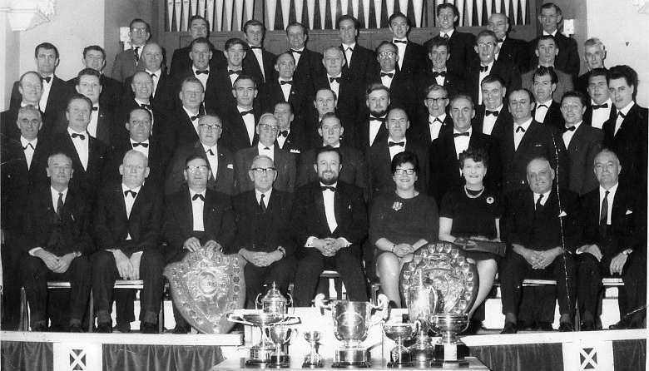
Alderley Edge, Barnsley (Male Voice), Barnsley (Vocal Group), Colne, Dearne, Elsecar, Fleetwood, Matlock Bath, (then to 1968) Barnsley, Colne, Ecclesfield, Elsecar and Ilkley. There was also a second placement at Blackpool, a third at Teesside and Colne (the second Colne festival later in the year).
1969 A first in Barnsley and four second placements at Blackpool, Harrogate, Hull and Ilkley and a third at Huddersfield.
1970 Mexborough (Challenge Cup), Mexborough (Male Voice), Mexborough (Vocal Ensemble), Hull and Whitby all realised first place whilst Teesside and Blackpool were third placements. The choir did attend Colne in this year but the results are unknown.
1971 First place was again awarded to the choir at Blackpool, Derby (Challenge Cup), Derby (Male Voice), Hull and Stockton. The choir attended the Llangollen Eisteddfod but results cannot be located.
1972 Derby (Challenge Cup), Derby (Male Voice), Freckleton (Champions Cup), Freckleton (Male Voice) and the Stockton 'A' were first prizes for the choir and Stockton 'B' was a second placement.
1973 Barnsley was a first and Llangollen was a tenth place out of eighteen international choirs.
1974 Freckleton only, result unrecorded.
1975 Colne festival realised two firsts and then three results are unrecorded for Biddulph, Harrogate and Whitby, although the choir is reported to have attended.
It seems that the choir didn't enter and festivals of competitions for the next three years.
1978 Llangollen, fourth out of 22 international choirs.
1979 The choir again tried for Llangollen but unfortunately only managed ninth place out of 25 and at The Manx Music Festival the same year, the result is unrecorded.
1980 At the Llangollen International Eisteddfod the choir managed a very well deserved second place out of eighteen. Their only competition recorded in this year.

1981 The choir was invited in this year to Linburg, Germany and took first place, 22 marks clear of its nearest rival. They also earned themselves a first at Stockton.
1982 Two firsts were won at Biddulph (Male Voice and Choral Championship) and records show they traveled to Pontrhydfendigaid, Wales but the results were not known.

1983 Colne (Choral Cup), second and Colne, (Male Voice), second and Llangollen, seventh.
1984 More first prizes were awarded at Blackpool and Ilkley, who also awarded the choir 'The most outstanding choir' trophy and the received a fourth prize in Teesside.
1985 Blackpool again awarded a first prize but the later results for the Llangollen attendance weren't recorded.
1986 Llangollen was again attended but out of 22 entrants the choir only managed fifteenth place.
1987 The choir went to Coalville and was awarded three firsts on the same day in three different categories and two different 'test pieces' in each category. They received second prize at Freckleton but the Nelson Arian competition result is not known.
1988 Attending Coalville again, the choir entered 4 quartets, receiving a first, second, third and fifth, and a first in the Male Voice Choir and Choir Open Large categories.
1989 The choir received a first in South Woodham Ferrers but only a thirteenth position, out of 23 in Llangollen. They travelled to Malta for the '1st International Maltese Music Festival' and the Huddersfield, Northern Male Voice Choir Championship. Details and results cannot be found for either.
1990 Six firsts are recorded at Biddulph, Coalville (x2), Derby (x2) and South Woodham Ferrers. A third place was received in Biddulph.
1991 Both Llangollen and the 3rd Malta International music Festival were attended but records are not available for reference.
1993 Of the three categories entered at Stanley, County Durham, the choir was awarded a first, a second and a third place.
1994 The choir again entered three categories at Coalville, (choirs open large) first, (male voice choir) first, (choirs open) second.
1995 Newcastle under Lyme gave the choir a first and they received two from Derby.
1996 The choir earned another first at Newcastle under Lyme and at Stanley the got a first, a second and won the Challengers Trophy.
1997 The National Male Voice Choir Championship of Great Britain in Rhyll was attended and the choir came fifth out of 13 entrants. They received first prize in Mexborough and a second in Whitby.
1998 A first was given at Biddulph in this year, the only one attended.
1999 At Whitby they entered two classes and got a third place in both.
2002 A first was awarded at Mexborough.
2003 The 1st Cornwall International Music Festival in Truro was attended and the choir was awarded fifth place, the first British choir from 18 entrants. They also got a second placing a Whitby.

A word of thanks.
This is perhaps a good opportunity to give recognition to the many hundreds of thousands of music lovers, worldwide, who have worked tirelessly to arrange, organise and see these types of festival through to their conclusion. It can be a logistical nightmare, with vast numbers of entrants attending, large audiences, as well as organising all the necessary ‘dignitaries’, adjudicators, stewards and marshals. Feeding and watering those that require it. Having attended many International ‘events’ in this country and abroad, this choir acknowledges the tremendous work you all do, long may it continue.
Thanks also to Mrs. Jean Weaver, members wife, for notifying me that, in 1945, a local journalist near Llangollen, Harold Tudor, had heard a Welsh milk boy singing a hymn, on a sunny Sunday morning, while on his rounds. Harold thought how wonderful it would be for people worldwide to hear this for themselves. Out of that came the idea of an International festival of music to encourage not only singing and playing, but long lasting and heartfelt friendships. He and his hardworking friends gathered the finance and built a network of contacts and in 1947, successfully staged the very first, soon to grow into, the Llangollen International Eisteddfod, an annual major Worldwide choral event, that has evolved into an all inclusive music and spoken word event.
This choir is very proud to have participated in this and many other prestigious events, and say ‘we helped, a little’.

Also, we must not forget The National Association of Choirs, having been established only four years longer than ourselves, do have guide lines on Festival Organisation and their Festivals and Music Officer is always willing to help. They can help any member with just about any situation, calling on their vast experience with almost all situations; they will be only too pleased to help. We would like to say a big thank you to all at the National Association of Choirs, over their 100+ years, for their tireless efforts on behalf of its members.

Members Role of Honour.
Below are all the names recorded as having been members of the choir from September 1924 to September 2024.
All names underlined are recorded honorary members with over 40 years service.
If any are omitted by accident, please accept our apologies and let us know, for our files.

ALLINSON W. ANDREWS F. ANNABLES A. ANNABLES K. ANNABLES W. APPELYARD T. APPS J. ARKLEY J Jnr. ARKLEY J Snr. ARTHUR D. ASCROFT J. ATKINSON A. AUSTIN J. T. BACON D. BAILEY J. BALL I. BARKER E. BARNETT L. BARRY K. BATES J. BATES W. BEARDSLEY K. BEECH. D. W. BECKHAM G. BENNETT M. BENNETT W. BIDDLESTON J.
BISBY C. BISBY S. BLESSED W. BOCKING J.D. BOOTHROYD C. BOWMER G. BRACKEN M. BRADY F. BRAMMER J. BREEZE B. BREWSTER R. BRIGHT G. BRINGLOW B. BROOKE N. BROOKES P. BROOKS C. BROWN G. BROWN J. BULLARS B. BULLARS B. BULLARS M. BULLARS R. BULLARS W. BURKENSHAW J. BUTLER G. BUTLER K. CADDICK B. CARTWRIGHT B. CARVER E. CARVER G. CARVER M. CARD H. Rev. CAREY S. CASE R. CASEY G. CASSIDY P. CHANDLER C. CHANDLER L. CHANDLER W. CLARK C. CLARKE J. CLARK T S. CLAYTON P. CLENNELL J. CLENNELL T. CLUBLEY E. COLDRON J. COLES D. COLES G. CONING F I. COOK A. COOK F. COOK L. COOKE L. COOPER D. COPLY G. CORCORAN F. COX D. CRAGGS N. CROCKET M. CROCKET R. CROOKES W. CROW A. CURREN D. CUNNLIFFE R. CUSWORTH S. DANIELLS Mr. DARBY B. DAVIS C. DAVIS D. DEAN D. DODD J. DOWLMAN I. DOWSON F. DUGDALE J E. DUNCAN P. DUTTON M. EDWARDS D. ELLIOTT G. EVANS D. EVANS H. EVANS O Miss. FEATHERSTONE R. FEELEY K. FELTON P. FERRIBY R. FISHER M. FITZGERALD G. FLECTER K. FOWLER B. FRETWELL C. GALLAMORE S. GARNER J. GATH A A. GENT B. GIBBS T. GLOVER W. GOAD P. GOOD C. GORING A. GOTHARD E. GREEN D. GREEN J. GREGORY J. GRIESON T. GRIFFITH T. GRIFFITHS K. GUEST T. GUNSLEY H. GUY A. HAIGH A. HALLET R. HANNER H. HARRISON P. HAYES I H. HAZELDINE H. HEAD J. HEATLEY B Mrs. HEDGE R. HEMSLEY F. HERMITAGE C. HILL B. HILL E W. HILL H. HILL I Mrs. HILL W. HIRSTALL R. HOLLAND H. HOLLIDAY. HOPE J. HOPES J. HOPPS J. HORNER H. HOUCHIN B. HOWARD W. HOWARTH B. HUNTINGTON T. HUGHES G. HULLEY T. HURD S. HYNER S. INGAMELLS F. JACKSON F. JACKSON J W. JACKSON J H. JACKSON P. JEFFERIES E. JEFFERIES J. JEFFERIES R. JERMY A W. JOHNSON A. JOHNSON C. JOHNSON F. JOHNSON G. JOHNSON N. JONES B T. JONES F. JONES J. JONES W. KEATING D L. KEATING J. KELLY E P. KELLY B. KIME G. KIRK W. KNIGHT R. KNIGHTON Mr. LAIDLER W. LARVIC Dr. LATHAM A. LATHAM E. LAWRENCE H. LEASLEY T. LEECH C. LEVITT G. LEWIN K. LOCKWOOD E. LODGE. C. LONG G. LOVE F. LOWRIE D. MACHIN C S. MALLENDER P. MANFREN G. MANSELL W. MARRISON W. MARSDEN G. MARTIN G. MARTIN J. MARTIN R. MASON C. MATHERS B. MAWSON A R. McLEAN D. McLEAN G H. McGREVY F. McGREVY M. McGREVY R. MEDLOCK J. MIDDLETON T. MILLAR A. MILLIGHAN F. MILLINGTON B. MINNIKIN J. MOLYNEAX F. MONKS S. MOORE K. MOORHOUSE B. MOORHOUSE F. MULLINS M. MYERS J. MYNETT A. NAYLOR T. NEEDHAM D. NEWRICH S V. NEWSUM R. NOBLE D. NYE P. OAKDEN K. OGLEY B. OGLEY R. OWEN R. PATTISON B. PAUL R. PEACE A J. PEACE G. PEARSON J. PEIRSON J. PEPPER A. PEPPER J. PETIT A. PHILLIPS L. PREWER D. PRINCE W. PROCTOR F. PULMAN B. PURCELL P. PYE V. QUAMBRO R. RATCLIFFE W. READMAN K. READMAN. W.(Snr) READMAN. W.(Jnr) REYNOLDS M. REYNOLDS T. RICH J. RICH T. RICHARDS D. RICHARDSON J. RIDGE D. RIDGE D G. ROBINSON G. ROBINSON R. ROBINSON S. ROCHESTER J. RODEN G J. ROEBUCK A. ROEBUCK C. ROPER J. ROPER R. RUSHFORTH R. SANDERSON D. SAUNDERS A. SCARROTT P. SCHORAH C. SCOTT F. SELBY J. SENIOR K. SHAKESHAFT P. SHAW D. SHAW G. SHAW J L. SIMMS A. SIMMS M. SMALL Mr. SMITH A. SMITH D. SMITH E. SMITH L. SNIPE P. SPEIGHT G. SPEIGHT H. SPEIGHT R. SPENCER W. STABLES C. STEWART P. STORER A. STRONG J. SUTTON J. SWIFFEN O. SWIFT W. TAYLOR M C. TAYLOR K. TEMPLE K. THOMPSON J. TOSELAND K. TOWNEND M. TRICKET F. TROW P. TUFF R. TURNER D. TURTON A. TURTON D. TURTON H. TURTON T. TYLER J. ULYATT G. VERNON L. WAKE D. WALDRON M. WALLACE M. WALTON J. WALSH K. WARD C. WARD F. WARD R. WATKINSON J W. WEAVER H E. WEAVER J. WEST W. WHITE D. WHITFIELD W. WILLIAMS L. WILLIAMSON W. WILKINSON G. WILSON D W. WILSON M. WOOD A. WOOD E. WOOD G. WOOD S. WORRALL L. WORDSWORTH G. WRIGHT C. WRIGHT G. WRIGHT H.
Bored with the troubles of life and want an interest?
† Are you at a loss, not knowing what to do with your spare time, not having an interest?
† Would you like to travel as part of your hobby, would you like to learn a skill or become proficient at something?
† If the answer to one or more of these questions is YES, then accept this challenge.
Come to listen to the Thurnscoe Harmonic Male Voice Choir and maybe have a try at singing. All the singers are ordinary blokes who have learned how to make a wonderful sound, by practicing.
THEY ARE NOT PROFESSIONAL MUSICIANS! THIS IS OUR HOBBY!
We are very fortunate to have a few brilliant soloists, and an octet / ensemble, but most of the ‘lads’ are harmony singers. Maybe you could follow their example, like thousands worldwide, share their comradeship, travel with them around the country and entertain people, while enjoying yourselves!

Where Do You Find Us?
The Choir rehearse twice weekly in the St John and St Mary Magdalene church hall, on Lockwood Street, Goldthorpe. S 63 9 JY. We practice from 7:30 p. m. to 9:00 p. m. on Wednesday evenings and from 11:00 a. m. to 12:30 p. m. on Sunday mornings throughout the year. (Except for Bank holidays)
At each rehearsal the Musical Director takes us through a series of part practices so that we can learn one of four parts. These are Tenor I, Tenor II, Baritone and Bass. When he thinks we can add another section, he will try two, and then three and so on until all parts sing together.
Using this method, we can learn new and refresh older items getting them as good as we can for performance.

INTERESTED?
We hold open house throughout the year, but we do ask that you be patient if we are rehearsing for an important event. Bring your partner along, have a listen or maybe even join in. We will even supply you with soft refreshments while you listen.

Member profiles.
Many of our members have worked at collieries; however, it is not compulsory. Our members are ordinary blokes from ordinary backgrounds and their occupations are wide ranging. We have Milkmen, train, lorry and bus drivers, plasterers, builders, electricians, bank managers, accountants, insurance rep’s, welders platers, draughtsmen, farmers, publicans, carers, technicians, firemen and even school teachers.
They travel from Nottinghamshire, Doncaster, Barnsley, Pontefract and Wakefield. (One chap used to travel from Scarborough).
For more information contact: - johnkeating9454@aol.com or Telephone 01226715172 or Mobile 07747891288. Visit our web site at :- www.thurnscoe-hmvc.com

Singing for Pleasure, Yours and Ours

